# 1. Updating Classical Swelling Theory with Loops: Experiments and Real Elastic Swelling Theory

Haley K. Beech, Nathan J. Rebello, Bradley D. Olsen

Department of Chemical Engineering, MIT

Understanding the effect of loop defects on polymer network properties is an important step to improving the accuracy of predictions. Equilibrium swelling ratios were measured for a set of gels with known loop fractions, extending prior work on loop counting with network disassembly spectroscopy. As expected, loopier gels demonstrated a higher degree of swelling due to a reduction of elastically effective strands. Building off of the Real Elastic Network Theory (RENT) developed for predicting linear viscoelasticity as a function of loops, the Real Elastic Swelling Theory (REST) incorporates RENT as the elasticity model in the classical Flory-Rehner swelling equation. To avoid error in estimation of the Flory-Huggins chi parameter, a non-dimensional master equation was derived, demonstrating a collapse across all good solvents. For gels with loop densities low enough to accurately assume loops were not correlated, REST was more accurate than models that do not account for loops. Despite the increased accuracy in REST, persistent deviations suggest the need for further improvements in elasticity models, especially in the high defect regime.

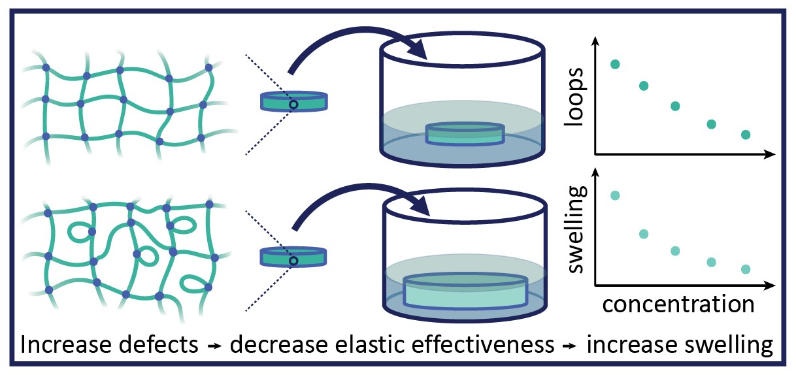

# 2. Active gels:from chemical microreactor to polymeric actuator

Baptiste Blanc, Zhenkun Zhang, Johnson Agyapong, Eric Liu, Hyunmin Yi, Seth Fraden

Massachussets Institute of Technology  
Nankai University  
Syracuse University  
Tufts University  
Brandeis University

We report on the synthesis and characterisation of Belousov-Zhabotinsky (BZ) hydrogels, materials with life like attributes made from polymers dissolved in ionic water. BZ hydrogel combines the ability to convert chemical energy into actuation with a sensing capability. We present a new synthesis technique to create spherical BZ gels in which the chemical and mechanical properties can be independently varied. With this modular system, we show that the mechanics of a BZ gel is controlled by its catalyst concentration and its bulk modulus. We also highlight the role of its surrounding media in its oscillation pattern. The Damkohler number, the ratio of chemical reaction to diffusion rates, is shown to govern the gel's oscillatory behavior. These findings are consistent with a Flory Huggins theory for polyelectrolytes and a Vanag Epstein model with diffusive coupling to its environment. Finally, we show that these active gels have collective behaviors that could be useful for increasing their chemomechanical energy conversion.

# 3. Polymer Metal–Organic Cage Networks for Plug-and-Play Heterogeneous Catalysis

Christopher M. Brown,a David J. Lundberg,a,b Jessica R. Lamb,a Denise Kleinschmidt,a Yasmeen Alfaraj,a Nathan J. Oldenhuisa,c* and Jeremiah A. Johnsona,d*

a Department of Chemistry, Massachusetts Institute of Technology, 77 Massachusetts Avenue, Cambridge, MA 02139, USA  
b Department of Chemical Engineering, Massachusetts Institute of Technology, 77 Massachusetts Avenue, Cambridge, MA 02139, USA  
c Present Address: Department of Chemistry, University of New Hampshire, 23 Academic Way, Durham, NH 03824, USA  
d David H. Koch Institute for Integrative Cancer Research, Massachusetts Institute of Technology, 77 Massachusetts Avenue, Cambridge, Massachusetts 02139, USA

Immobilization of homogeneous catalysts onto solid supports to improve recyclability is often a trial-and-error process limited by a lack of orthogonal chemical reactions to append the catalyst to a given support. Furthermore, the immobilization environment is largely dictated by the chemistry required to attach the catalyst to the support. Here, we introduce a “plug-and-play” heterogenous catalysis platform that overcomes these challenges. Our approach leverages endohedrally catalyst-functionalized, self-assembled Pd12L24 metal–organic cages (MOCs) crosslinked by polymers. Through decoupling catalyst incorporation and environment (within the pores of MOCs) from the physical properties of the support (polymer matrix), this simple strategy can be used to easily enhance the recyclability of various catalyst systems (e.g., TEMPO, Au(I), and Mn-salen) and enable catalysis in environments where homogeneous catalyst analogs are not viable.

# 4. Biophysical Characterization of Respiratory Secretions in Severe SARS-CoV-2 (COVID-19) Infections

Pamela Cai1, Michael J. Kratochvil2,3, Gernot Kaber2, Elizabeth B. Burgener2, Egan Peltran2, Graham Barlow2, Mark R. Nicolls4, Michael G. Ozawa5, Donald P. Regula5, Nadine Nagy2, Carlos E. Milla6, Angela J. Rogers4#, Andrew J. Spakowitz1, Sarah C. Heilshorn3# and Paul L. Bollyky2#

1 Department of Chemical Engineering, Stanford University, 443 Via Ortega, Stanford, CA 94305  
2 Division of Infectious Diseases and Geographic Medicine, Dept. of Medicine, Stanford University School of Medicine, Beckman Center, 279 Campus Drive, Stanford, CA 94305  
3 Department of Materials Science and Engineering, Stanford University, 476 Lomita Mall, Stanford, CA 94305   
4 Department of Pulmonology and Critical Care Medicine, Stanford University School of Medicine, Lane 235, 300 Pasteur Drive, Stanford, CA 94305  
5 Department of Pathology, Stanford University School of Medicine, Lane 235, 300 Pasteur Drive, Stanford, CA 94305  
6 Center for Excellence in Pulmonary Biology, Department of Pediatrics, Stanford University, 770 Welch Road, Stanford, CA 94305

Thick, viscous respiratory secretions are common in severe cases of COVID-19 disease and greatly contribute to breathing difficulty. Understanding the polymeric composition and the rheological properties of these secretions can inform the development of treatments to improve the respiratory function of these patients. After measuring the composition of respiratory secretions collected from intubated COVID-19 patients and controls, we found that DNA content and hyaluronan content were greatly elevated in COVID-19 sputum. Across all patients, COVID-19 sputum exhibited a wide distribution in rheological properties, which were measured using dynamic light scattering microrheology. Respiratory secretions from COVID-19 patients had a statistically significant increase in storage moduli compared to healthy controls. We explored the possibility of reducing sputum viscosity by treating the aspirates enzymatically with hyaluronidase or DNase, which degrade hyaluronan and DNA, respectively. Interestingly, there was a strong positive correlation between the shear modulus of COVID-19 sputum and the effect of these enzymes. These results suggest that DNA and hyaluronan may be viable therapeutic targets in COVID-19 infection and could be targeted with FDA-approved enzymes already clinically used for other indications.

# 5. 3D printing of salt dough for accessible hands-on education and digital craft

Cécile A.C. Chazot(*), Joseph D. Sandt, Thibaut Divoux, Gareth H. McKinley, A. John Hart.

Cécile A.C. Chazot – Department of Materials Science and Engineering, MIT  
Joseph D. Sandt – N/A  
Thibaut Divoux - Univ Lyon, Ens de Lyon, Univ Claude Bernard, CNRS, Laboratoire de Physique  
Gareth H. McKinley, A. John Hart - Department of Mechanical Engineering, MIT

Today, 3D printers—especially desktop fused filament fabrication (FFF) machines—have made their way into many people’s lives and enable on-demand fabrication of parts with mechanical properties suitable for many “around the house” applications. In this context, one emerging application of FFF is early childhood education, through the development and practice of 3D design skills, and fabrication of toys and decorative artifacts. However, particulate emissions from FFF printers and the high nozzle temperature required to melt plastic present potential hazards to children who use these printers. Additionally, the concept of having children and adult crafting toys and figurines is not new, having existed for centuries in the context of arts and crafts. Salt dough, as one example, is a modeling material made from a mixture of flour, salt, and water, which makes it completely safe (but not particularly tasty) to eat. It is often used to make ornaments, jewelry, or small sculptures, which harden when baked in an oven or microwave. Salt dough comes in a wide range of colors (by addition of food coloring or painting after drying) and textures (by adjusting the ingredient ratios). Here, we demonstrate extrusion 3D printing of salt dough in ambient (without requiring heating), using a custom-built desktop printer that could be produced at a cost comparable to current polymer FFF systems. We study how the composition of the dough influences its rheological properties, and therefore its printability, and realize complex 3D shapes after drying/baking. We discuss the potential use of salt dough printing in education and craft settings.

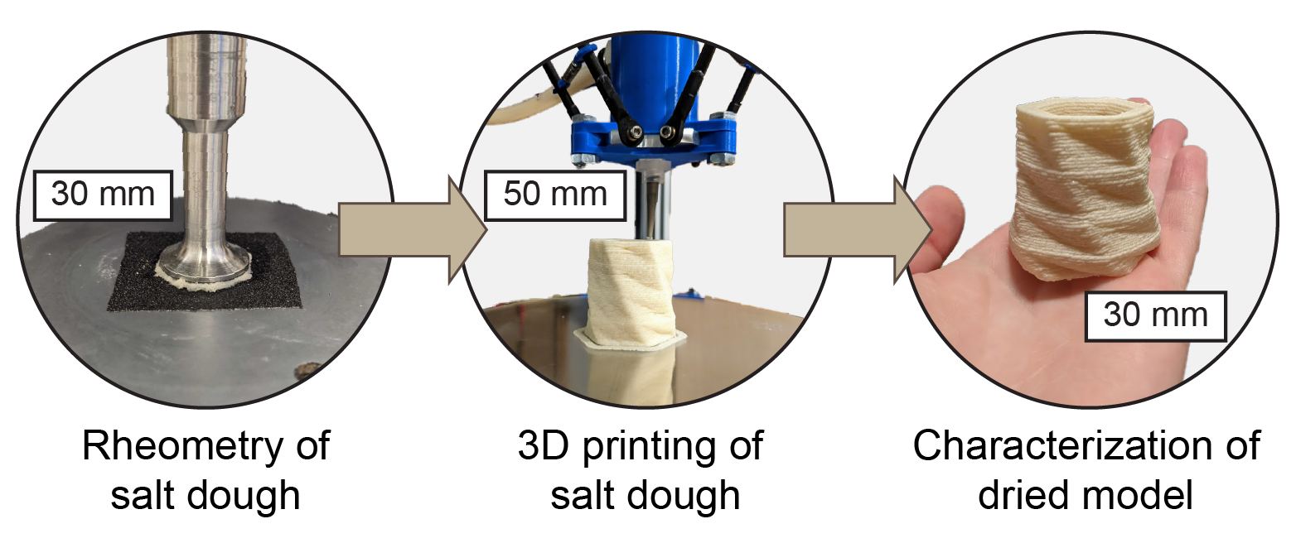

# 6. Design and Use of a Thermogelling Methylcellulose Nanoemulsion to Formulate Nanocrystalline Oral Dosage Forms

Liang-Hsun Chen, Patrick S. Doyle*

Department of Chemical Engineering, Massachusetts Institute of Technology

Oral drug products have become indispensable in modern medicine because of their exceptional patient compliance. However, poor bioavailability of ubiquitous low water-soluble active pharmaceutical ingredients (APIs) and lack of efficient oral drug formulations remain as significant challenges. Nanocrystalline formulations are an attractive route to increase API solubility, but typically require abrasive mechanical milling and several processing steps to create an oral dosage form. Utilizing the dual amphiphilic and thermoresponsive properties of methylcellulose (MC), a new thermogelling nanoemulsion and a facile thermal dripping method are developed for efficient formulation of composite particles with the MC matrix embedded with precisely controlled API nanocrystals. Moreover, a fast and tunable release performance is achieved with the combination of a fast-eroding MC matrix and fast-dissolving API nanocrystals. Using the versatile thermal processing approach, the thermogelling nanoemulsion is easily formulated into a wide variety of dosage forms (nanoparticle suspension, drug tablet, and oral thin film) in a manner that avoid nanomilling. Overall, the proposed thermogelling nanoemulsion platform not only broadens the applications of thermoresponsive nanoemulsions, but also shows great promise for more efficient formulation of oral drug products with high quality and tunable fast release.

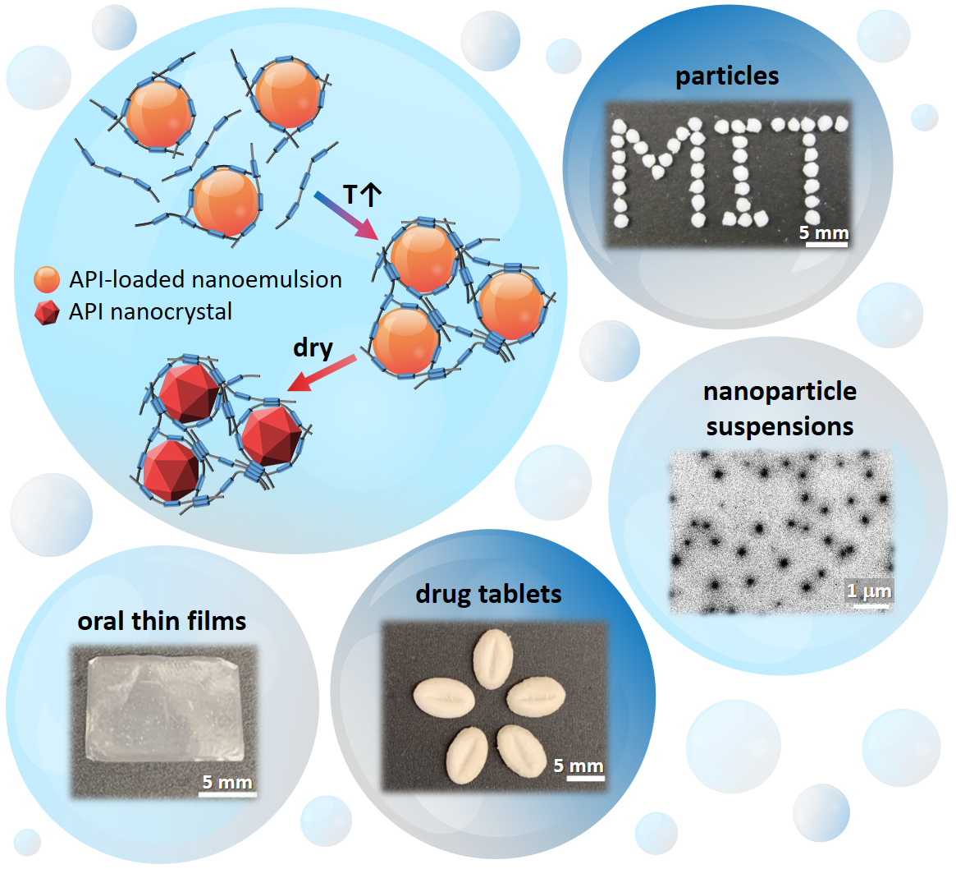

# 7. Assembling polymer chains into hierarchically ordered supramolecular nanofibers

Christopher B. Cooper, Jiheong Kang, Yikai Yin, Zhiao Yu, Hung-Chin Wu, Shayla Nikzad, Yuto Ochiai, Hongping Yan, Wei Cai, and Zhenan Bao

Stanford University

Polymeric materials in nature regularly employ ordered, hierarchical structures in order to perform unique and precise functions. Importantly, these structures are often formed and stabilized by the cooperative summation of many weak interactions as opposed to the independent association of a few strong bonds. Here, we present our work on synthetic, flexible polymer chains with periodically-placed and directional dynamic bonds that collectively assemble into supramolecular nanofibers when the overall molecular weight is below the polymer’s critical entanglement molecular weight. This leads to the counterintuitive result that long polymer chains have faster dynamics than shorter polymer chains of identical chemical composition. The formation of nanofibers increases the bulk film modulus by over an order of magnitude and delays the onset of terminal flow by more than 100°C, while still remaining solution processable. In this talk, we will outline the key aspects of polymer molecular design that enable self-assembly into these supramolecular nanofibers along with coarse-grained molecular dynamics simulations that generalize these results to any flexible backbone with reversible bonding units. This work contributes to our fundamental understanding of designing biomimetic functional materials.

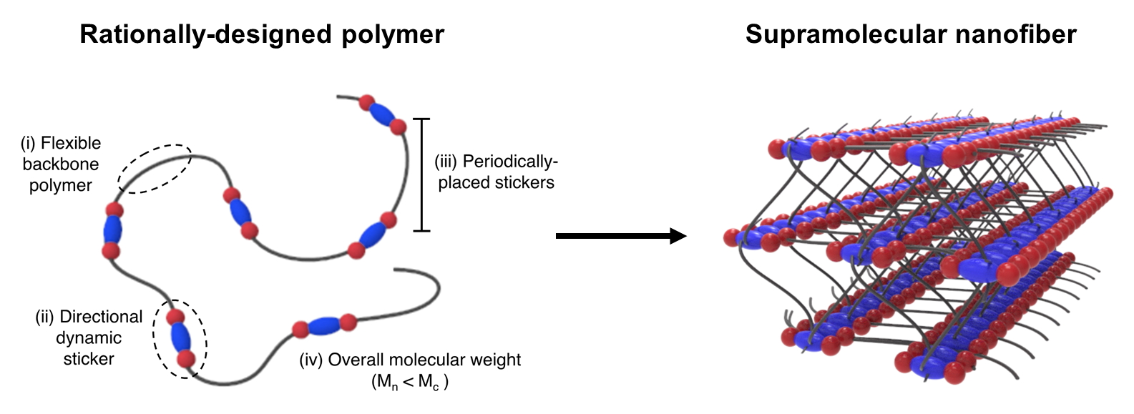

# 8. Facilitation of electrospun alginate-based nanofiber for the encapsulation and delivery of live bacteria into the gut

Emily Diep and Jessica D. Schiffman

Department of Chemical Engineering at the University of Massachusetts, Amherst

Ailments such as inflammation, obesity, autism, and depression have been linked to specific communities of gut bacteria. Therefore, it is imperative to develop protective delivery matrices that can safely transport probiotic bacteria into the gut. Particularly, electrospun nanofibers have risen in popularity due to their high surface area to volume ratio and tunable properties that are ideal for drug delivery systems. This project aimed to encapsulate live bacteria into electrospun, alginate-based nanofibers. Alginate is a polysaccharide that is compatible with both the human body and bacteria cells. When crosslinked with calcium ions, the alginate hydrogel is stable in low pH environments like that of the stomach and swells in high pH environments providing the potential for targeted delivery of bacteria into the intestines where most gut bacteria reside. The rigid structure and high conductivity of alginate chains typically make it difficult to process into nanostructures. First, we systematically studied the effects of a carrier polymer, polyethylene oxide, and an FDA-approved surfactant, polysorbate 80, on the surface tension and conductivity of alginate solutions to facilitate smooth fiber formation during electrospinning. Second, we introduced our model bacterium, Escherichia coli K12, into the solution to be encapsulated during electrospinning. The addition of the bacterial suspension shifted the solution properties causing fiber beading. The system was then reoptimized to counter the effects of adding bacteria to the solution. Fluorescence microscopy and scanning electron microscopy were able to confirm the encapsulation of live bacteria in alginate-based nanofibers. Finally, bacterial enumeration techniques were utilized to determine the bacterial loading in the fibers as 2.74 × 10^5 CFU/g.

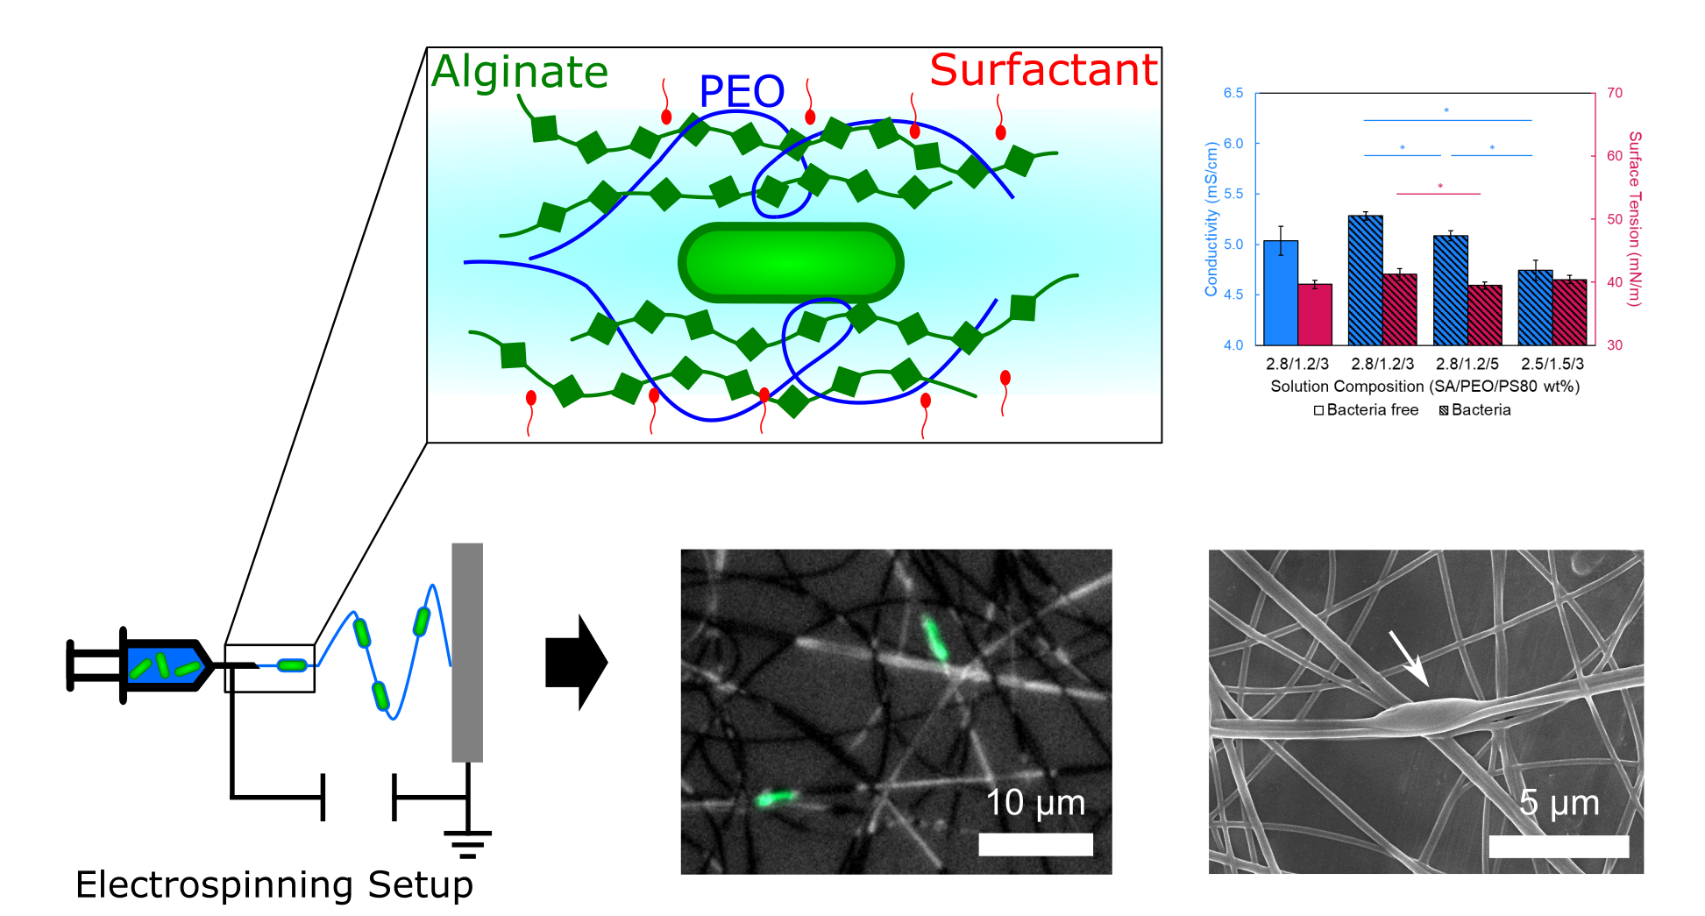

# 9. Curvature-Templated Patterns in Self-Wrinkling Vapor-Deposited Polymer Films

Robert N. Enright and Laura C. Bradley

Department of Polymer Science and Engineering, University of Massachusetts Amherst, Amherst, Massachusetts 01003, USA

Materials with complex curvature and microstructured surface topography allow scientists to more closely replicate surfaces observed in nature. Here, we demonstrate control over surface patterns formed by self-wrinkling polymer films deposited on soft substrates with various curvature profiles via initiated chemical vapor deposition. We examine the effects of surface curvature, boundary geometry, and deposition conditions on the resulting wrinkle pattern and orientation. We experimentally affirm the principle that the roundness of wrinkles increases with increasing interface curvature on substrates with interface profiles resembling cylinders and cones and on repetitive surfaces with saddles and bowls. Furthermore, under certain deposition conditions, wrinkles orient as a result of anisotropic curvature and/or stress concentrations at the boundaries of the soft substrate. The ability to control the character of wrinkle patterns via changes to both the local and global substrate shape provides a route to generate materials with contrived surface micro-topography.



# 10. Microfluidically produced hydrogel microcarriers for improved cell culture environment uniformity

Camille Farruggio, Brandon Krupczak, Nishtha Singh, Krystyn Van Vliet

Camille Farruggio (MIT, SMART CAMP)  
Brandon Krupczak (MIT, SMART CAMP)  
Nishtha Singh (SMART CAMP)  
Krystyn Van Vliet (MIT, SMART CAMP)

Cell therapy manufacturing uses live biological cells as therapeutic agents for applications from cancer treatments to improved wound healing. The safety and efficacy of such treatments is dependent on delivery of a treatment dose with the greatest possible uniformity and specificity of cell phenotype. In-vitro cell culture is a necessary part of cell therapy manufacturing processes during treatment development and expansion to attain sufficient cell numbers for a treatment dose. However, cell phenotype can depend sensitively on mechanical, chemical, and other environmental cues during expansion, and many current culture techniques introduce heterogeneity into cell populations. We here develop gelatin-based microcarriers for bioreactor-based culture of attachment-dependent cells such as mesenchymal stem cells (MSCs) using micrifluidic droplet production. Investigation of the effects of improved uniformity in the curvature, stiffness, and boireactor conditions presented to the cell using this tunable culture platform on overall cell homogeneity is discussed. Initial experiments have indicated a potential correlation between this culture substrate and the preservation of multipotency in MSC culture. Refinement and implementation of these gelatin microspheres could improve the consistency and yield of therapeutically desirable cells, decreasing heterogeneity in cultured cell products, increasing the ability to prime cells towards desirable phenotypes, and increasing the safety and efficacy of cell therapies based on adherent cells such as MSCs.

# 11. Effect of Chemical Identity and Morphology on Water and Salt Transport in Amphiphilic-Zwitterionic Copolymer Membranes

Ria Ghosh, E. Bryan Coughlin

Department of Polymer Science and Engineering, University of Massachusetts Amherst

Amphiphilic copolymers have gained a broad platform of research interest attributed to their superior self-assembly properties (globular or extended) over a broad range of pH, temperature, and ionic strength. Polyzwitterions have attracted special attention due to their hydrophilicity, charge sensitivity (net charge can be negative or positive) and coulombic attraction of the opposite charges over a range of different environments. These properties made them a widely popular material in the field of tailoring “smart” stimuli responsive systems, self-healing hydrogels, and water transport membranes. The primary focus of this work is to tailor amphiphilic-zwitterionic (A-Z) block copolymers that are mechanically robust membranes and to then correlate the effect of molecular weight, morphology and zwitterionic identity on water, and salt transport. A set of synthesized neutral amphiphilic block copolymer with PDMAEMA as one of the blocks and another block with low Tg to provide mechanical integrity of the chain with different volume fractions of hydrophilic PDMAEMA block will be synthesized using reversible addition-fragmentation chain transfer (RAFT) polymerizations to control the molecular weight and copolymer composition. The precursor polymers will be treated with 1,3-propane sultone, β-propiolactone and n-Butyl substituted phospholane for post-polymerization nucleophilic ring-opening reactions to give Poly (sulfobetaine methacrylate) (PSBMA), Poly (carboxybetaine methacrylate) (PCBMA) or poly[2-{2-(Methacryloyloxy) ethyl dimethylammonium} ethyl n-butyl phosphate] (PMBP) copolymers with different compositions, morphology and zwitterionic moieties. These polymers combine both stimuli responsiveness and higher hydrophilicity of zwitterionic polymers and physical conformations of amphiphilic copolymers in their water and salt transport.

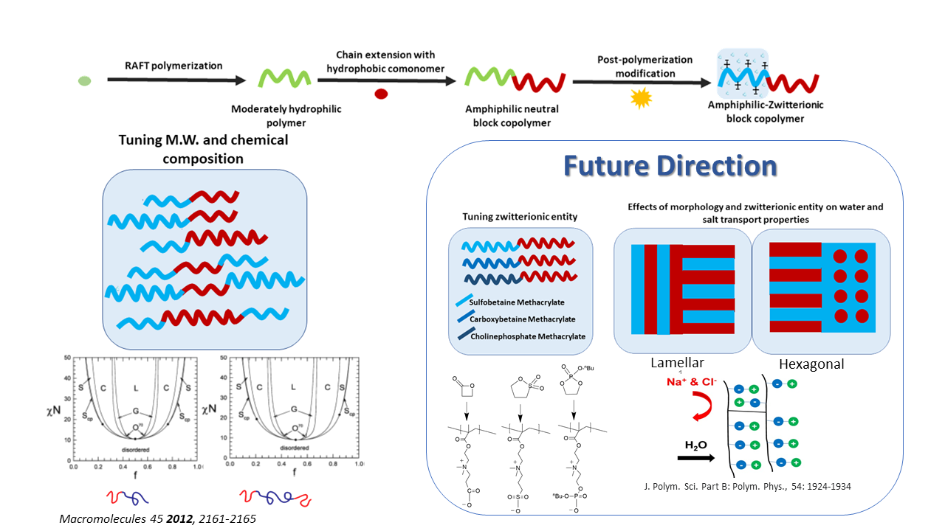

# 12. Understanding the effects of intracrystallite and intercrystallite structuring on charge transport in conjugated polymers

Kaichen Gu, Chad R. Snyder, Jonathan W. Onorato, Yucheng Wang, August W. Bosse, Ruipeng Li, Esther Tsai, Christine K. Luscombe, Rodney D. Priestley, and Yueh-Lin Loo

Kaichen Gu (Princeton University)  
Chad R. Snyder (National Institute of Standards and Technology)  
Jonathan W. Onorato (University of Washington)  
Yucheng Wang (Princeton University)  
August W. Bosse (ExxonMobil)  
Ruipeng Li (Brookhaven national lab)  
Esther Tsai (Brookhaven national lab)  
Christine Luscombe (University of Washington)  
Rodney Priestley (Princeton University)  
Yueh-Lin Loo (Princeton University)

Solution-processable conjugated polymers are promising candidates for next-generation flexible electronics. Yet, it remains challenging to predict how conjugated polymers will perform in devices because the polymer active layers are semicrystalline and the details of the heterogeneous microstructures strongly impact charge transport. In this thesis, we systematically explored the effects of microstructure on charge transport in conjugated polymers, primarily focusing on a family of model poly(3-hexylthiophene), or P3HT.  
To circumvent the challenges associated with determining the molecular weights (MW) and molecular weight distributions (MWD) of conjugated polymers via conventional chromatographic methods, we demonstrated diffusion-ordered NMR spectroscopy (DOSY) to characterize their size and size distribution based on their hydrodynamic properties. With the MW and MWD of P3HT samples fully characterized, we investigated the structural origins for the generally-acknowledged MW- and MWD-dependence of their charge-transport properties. We quantified, for the first time, the role of intercrystallite tie chains on macroscopic charge transport and determined a critical tie-chain fraction, below which domain interconnectivity, and above which intradomain order, limit charge transport. Our analysis implicates the importance of long and rigid polymer chains in forming percolated networks to support macroscopic charge transport.

The presence and extent of tie-chain connectivity necessarily affect the mechano-electrical response of polymer films upon deformation. We showed that the presence of tie chains is critical to achieving strain-induced structural alignment, and accordingly, improvements in macroscopic charge transport in the strain direction. When the tie-chain fraction is instead sub-critical, the polymer film undergoes brittle fracture and the electrical properties suffer consequently. We demonstrated the promise of leveraging tie-chain fraction as a practical tuning knob for effecting the mechano-electrical properties of conjugated polymers to meet specific application needs.

The specifics of processing conditions impact the solid-state morphology of solution-processed polymers, and therefore, their charge-transport properties. We showed that the detrimental effect on charge transport of tie-chain pull-out during crystallite thickening upon post-deposition thermal annealing can overshadow the benefits of improved crystallinity. Our findings supported the notion that high crystallinity does not guarantee efficient charge transport. Instead, the unifying requirement for macroscopic charge transport is sufficient interconnectivity between crystallites.

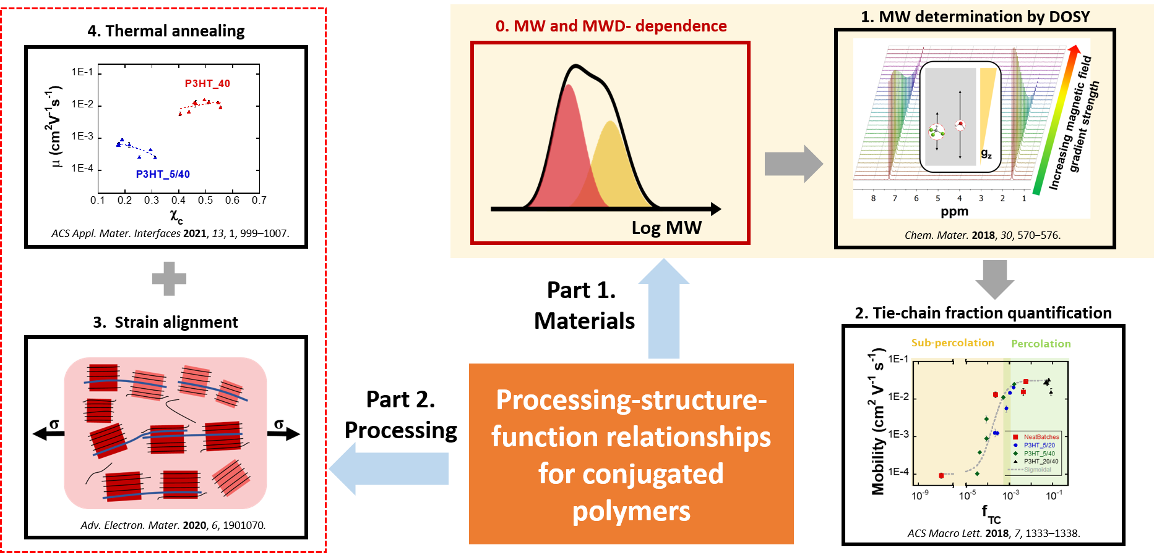

# 13. Characterizing Synthetic Random Heteropolymers through Simulation

Shayna Hilburg, Alfredo Alexander-Katz

Department of Materials Science and Engineering, MIT

Synthetic random heteropolymers have complex properties that make them capable of interfacing favorably with proteins and mimicking biomolecular systems. Atomistic molecular dynamics simulations allow the investigation of these random heteropolymers assembled in solution at the nanoscale, bridging the gap between angstrom-scale NMR and bulk characterization. Here, we present the impact of composition, molecular weight, and solvent environment on a single-chain methacrylate-based synthetic heteropolymer system. Our findings show that while a wide variety of individual sequences exist in a random heteropolymer system, their physicochemical properties are dominated by the overall compositions and monomer arrangements that arise from the synthesis process, making their properties generally tunable. The detailed understanding of the effect of composition and environment on polymer behavior we provide enables heteropolymer design for a variety of polymer nanoparticle applications.

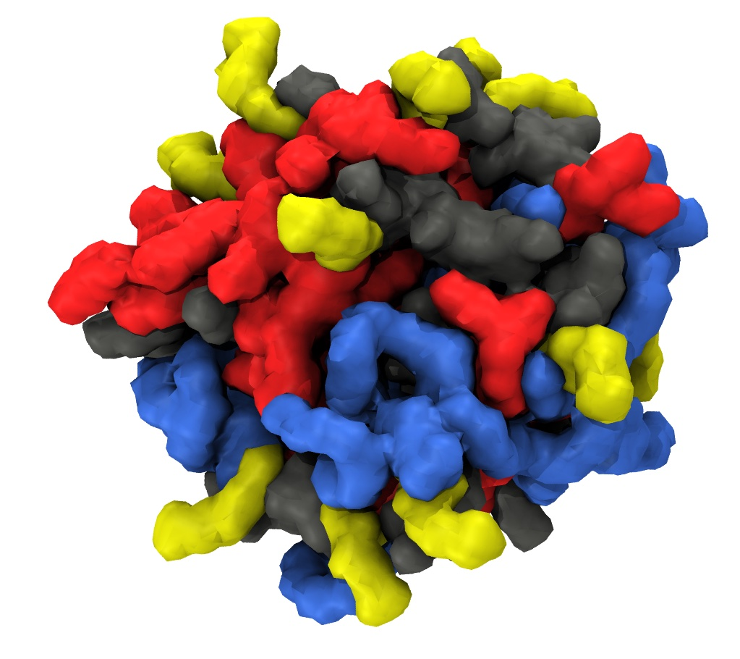

# 14. Mechanically Active and Tunable Extracellular Matrix Fibers

Gwendolyn A. Hoffmann, Matthew M. Jacobsen, Matthew D. Layne, Joyce Y. Wong, and Michael L. Smith

Department of Biomedical Engineering and Department of Biochemistry, Boston University

Several extracellular matrix (ECM) proteins are known to have mechanosensitive ligand binding. For example, fibronectin (FN) exhibits strain-sensitive binding to a variety of ligands, such as interleukin-7 (1) and integrins (2,3), which in turn alter cell behavior including adhesion and migration3. This suggests ECM fiber strain could be harnessed in biomaterials for mechanically-actuated control of cell behavior. However, most naturally occurring ECM fibers are difficult or impossible to extract for scientific studies or as mechanoresponsive materials. Here we aim to develop mechanically active and tunable fibers of ECM proteins to manipulate cell behavior.

We developed a powerful, yet simple, wet spinning technique to generate a diverse set of proteinaceous fibers including FN, laminin, collagen, silk fibroin, and albumin: moreover, the relationship between molecular weight and concentration required to form a continuous fiber follows a power law, enabling rapid fiber formation with specific compositions. To determine how composition impacts fiber mechanical properties, we generated collagen fibers with and without ACLP, a collagen-binding protein linked to the connective tissue disease Ehlers-Danlos Syndrome (5). The addition of ACLP to wet-spun collagen fibers improves their mechanical properties (modulus, strength, toughness) (6). Furthermore, addition of laminin or collagen IV to pulled FN fibers modulates their mechanical properties, which demonstrates that composition can be used to alter mechanical properties of fibers generated with multiple techniques. Using a strain-sensitive FN-binding peptide, we found that FN-silk wet-spun composite fibers retain strain-sensitive ligand binding properties. Our system generates mechanically active fibers and could also be applied to determine which ligands and growth factors have strain-dependent changes in binding to ECM proteins, with implications in (patho)physiological processes involving mechanical changes, such as fibrosis.

Our method of producing composite ECM fibers can generate mechanoresponsive materials with tunable mechanical properties for applications such as tissue engineering that require specific cellular responses, and can be used to assay for strain-dependent binding of ligands.  
  
References:   
1. Ortiz Franyuti D, et al. Nano Letters. 2018;18(1):15-25.   
2. Cao L, et al. ACS Nano. 2017;11(7):7110-7117.  
3. Hubbard B, et al. J. Cell. Physiol. 2016;231(8):1728-1736.   
4. Bradshaw MJ, et al. Acta Biomater. 2019;88:78-85.   
5. Blackburn PR, et al. Am. J. Hum. Genet. 2018;102(4):696-705.   
6. Vishwanath N, et al. J Biol Chem. 2020;295(28):9725-9735.

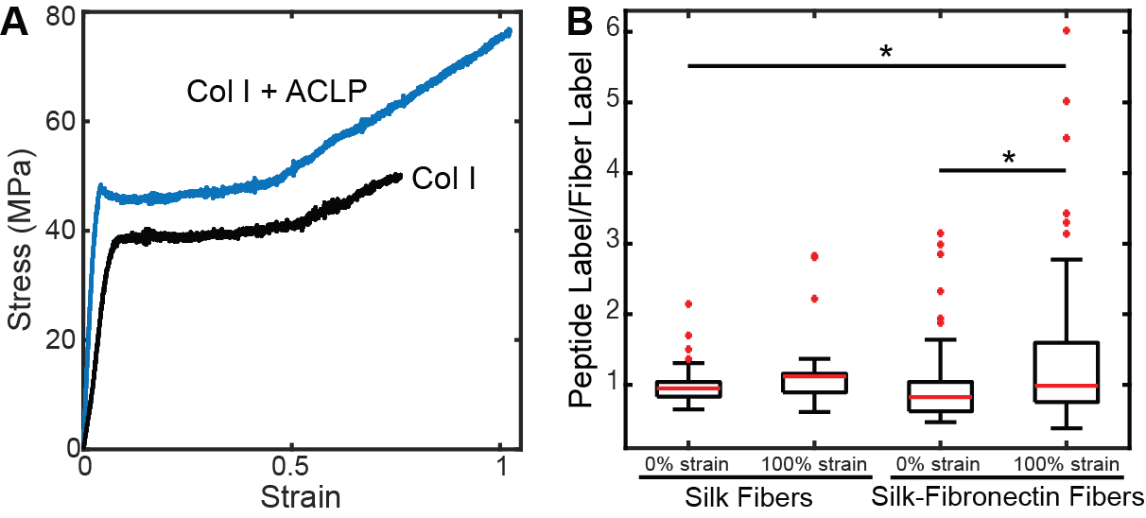

# 15. Inverse Design of 3D Nanostructure through Directed Self-Assembly of Block Copolymers

Hejin Huang  
Alfredo Alexander-Katz

Massachusetts Institute of Technology

Directed self-assembly (DSA) of block copolymers (BCP) provides a powerful tool to fabricate complex 2D nanopatterns at small length scale. Fabrication of complex 3D nanostructures by BCP, however, remains a challenge. Here, we introduce a method based on self-directed self-assembly, that utilizes artificial intelligence tools for inverse design of 2D and 3D nanostructures. The methods presented here encompass rapid algorithms for characterizing the internal structures of BCP morphologies from the atom coordinates generated by MD simulations to substrate optimizing algorithms for developing effective routes to propagate information from the substrate into the BCP film. We will show several examples in which this AI engine is applied. Novel 2D and 3D nanostructures have been achieved.

# 16. Determination of β Phase Crystalline Fraction in Electrospun Poly(vinylidene fluoride) Fibers

Anuja S. Jayasekara  
Nelaka D. Govinna  
Peggy Cebe

Department of Physics and Astronomy  
Tufts University

The β-crystallographic phase of poly(vinylidene fluoride), PVDF, is often used in fabricating piezoelectric and pyroelectric materials. However, the specific equilibrium heat of fusion of β-PVDF has not yet been definitively determined. The difficulty in this measurement arises from the necessity of obtaining solely beta phase crystals, as well as in quantifying the overall degree of crystallinity. Here, we investigate the crystalline fraction of β-PVDF in fibers prepared by electrospinning from solutions of 12.5 wt.% and 15.0 wt.%. This preparation produces dominantly beta phase crystals by using simultaneous application of mechanical and electrical forces to stretch the polymer fibers thus favoring the all trans chain conformation. The crystalline fraction of a specific crystallographic phase was determined by wide angle X-ray scattering and Fourier-transform infrared spectroscopy peak deconvolution. Melting enthalpy of the crystals was determined by differential scanning calorimetry. A preliminary estimate of the equilibrium heat of fusion of polar (electroactive) phases of PVDF is presented.

# 17. Glass transition of bulk random heteropolymers

Tianyi Jin, Shayna L. Hilburg, and Alfredo Alexander-Katz

Tianyi Jin: Department of Chemical Engineering, MIT  
Shayna L. Hilburg, and Alfredo Alexander-Katz: Department of Materials Science and Engineering, MIT

A random heteropolymer (RHP) consists of two or more monomers in a random sequence. It has been shown that it can be used in drug delivery [1] and also known to preserve protein function in foreign environments [2].

A previous study showed that in water, RHP backbone was frozen at room temperature with multiple stable globule morphologies [3]. The heterogenous interfaces showed a similarity as naturally ordered proteins.

In this study, we further investigate that RHP melts show a distinct glass transition behavior compared to glassy PMMA and viscous PEHMA. The mobility varies with compositions due to ionic clusters. Spatial heterogeneities during cooling are also found.

# 18. Synthesis of cleavable and exchangeable polymers through the incorporation of siloxane linkages

Roshni John Chethalen, Anne Radzanowski, E. Bryan Coughlin

Department of Polymer Science and Engineering - University of Massachusetts Amherst

Plastics have fundamentally shaped modern life, however a significant challenge arises when examining plastic end-of-life options. One of the major barriers to degradation/depolymerization of commodity plastics is the chemical and thermal resistance of the strong C-C bonds in the polymer backbone. The introduction of dynamic covalent bonds as a sort of active linker would allow for the cleavage and exchange of polymer backbones with possible avenues for reprocessing/recycling. Synthesis of a new class of difunctional atom transfer radical polymerization (ATRP) initiators containing MM-disiloxane linkers allowed for incorporation of the linkage into the backbone of commodity polymers such as polystyrene (PS) and poly(methyl methacrylate) (PMMA). These siloxane linkages are cleavable using a variety of catalysts including acids, bases and fluoride sources. Attempts to study the cleavage and exchange between the siloxane-containing polymers and 1,3-divinyltetramethyldisiloxane (DVTMS) have shown successful cleavage of the polymer marked by a reduction of the polymer molecular weight by half. 1H and 13C NMR studies conducted on the polymers indicate the presence of vinyl end groups. These end-capped vinyl-functionalized polymers provide possible paths to a variety of further chemistries such as graft polymerizations. The results of the cleavage experiments reveal the potential of utilizing dynamic covalent bonds and other active linker strategies in the chemical upcycling of plastics. The incorporation of siloxane linkages may be one step towards developing a much-needed closed plastics loop.

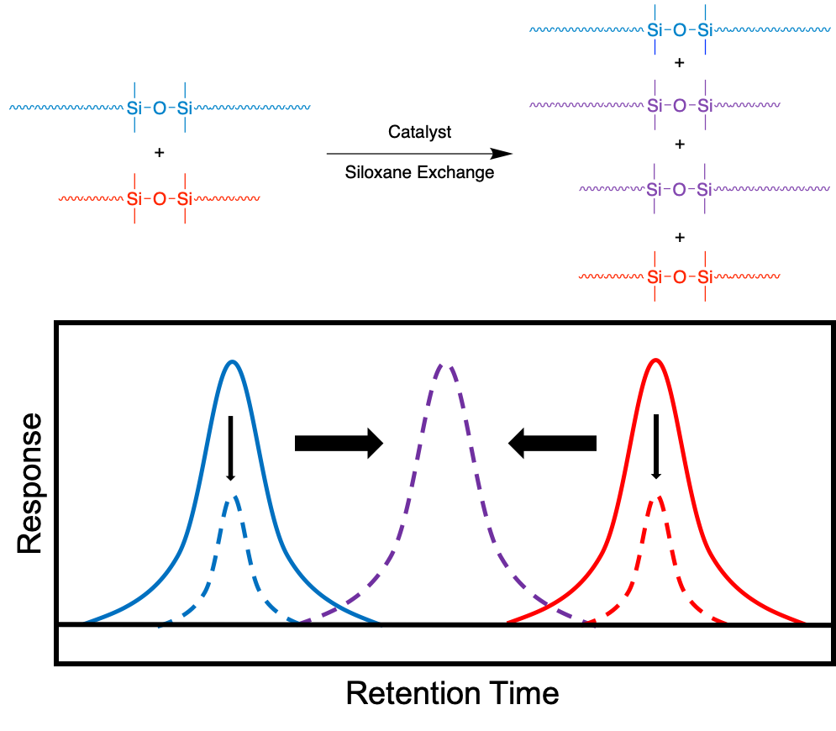

# 19. Understanding the Role of Dendrimer Surface Modifications for Osteoarthritis Drug Delivery

Brandon M. Johnston1,2  
Alan J. Grodzinsky3,4,5  
Paula T. Hammond1,2

1Department of Chemical Engineering, MIT  
2Koch Institute for Integrative Cancer Research  
3Department of Biological Engineering, MIT  
4Department of Mechanical Engineering, MIT  
5Department of Electrical Engineering and Computer Science, MIT

Osteoarthritis is a debilitating joint disease that degrades a patient’s articular cartilage until a large lesion forms in the otherwise smooth surface. Currently, there are no disease modifying osteoarthritis drugs that are capable of slowing the progression of the disease. This is mainly due to the avascular nature of the articular cartilage which prevents therapeutic drug doses from reaching their target site after systemic delivery. In addition, locally injected therapies are quickly eliminated from the joint space by synovial fluid turnover without efficiently interacting with the dense, negatively-charged matrix. As a result, a number of drug delivery formulations have been explored for the sustained delivery of osteoarthritic therapies.

Previously, positively-charged, multivalent carriers of size less than 15 nm have shown to utilize electrostatic interactions to bind to and penetrate through articular cartilage faster than they can be cleared from the joint space. Among those studied are poly(amidoamine) dendrimers (PAMAM) which consist of a hierarchically branched polymer with a high surface density of cationic primary amines. The cytotoxicity of the polymer’s high charge density can be mitigated by covalently conjugating poly(ethylene glycol) (PEG) to its surface. When locally introduced into the joint of a rat model, these PAMAM-PEG conjugates have shown to improve the retention time of a bound therapy ten-fold versus the free drug. Though literature shows that surface-bound PEG is able to enhance tissue penetration while reducing uptake and cytotoxicity, the role that the PEG corona plays in these interactions has not been explored. Here, using a novel charge-based method to characterize the PEG corona, we found that PEG chains are capable of non-covalently interacting with PAMAM primary amines, shielding those amines from participating in electrostatic interactions. This shielding results in a reduction in the number of charged accessible amines, or the amount of primary amines accessible on the surface of the conjugate that are able to electrostatically bind to cartilage. Data suggests that these non-covalent interactions weaken and increase reversibility of electrostatic binding to cartilage. In addition, we found that the dendrimer-cartilage interactions are dependent on the PEG chain length and the accessible charged amines: tissue uptake increases and uptake kinetics are faster with shorter PEG chains and increasing accessible charged amines, whereas cartilage penetration depth decreases. Further investigation will assess translation in vivo to optimize the conjugate for the sustained delivery of osteoarthritic therapies.

# 20. Microphase Separation of Hydrogen-Bonded Polystyrene-Polydimethylsiloxane Copolymer Blends

Jaechul Ju, Ryan Hayward*

Chemical and Biological Engineering, University of Colorado Boulder, Boulder, CO 80303, USA

Self-assembled morphologies play a pivotal role in developing material properties. Thus, it would drive innovation if the transition of self-assembled structures is controlled by external stimulus. Hydrogen bonding (H-bonding) as secondary interaction has combined with a polymer blend system. It can be dissociated and re-associated as a function of temperature, developing reversible bonds. In our system, phenol (Ph) and pyridine (Py) are attached in pendent to polystyrene (PS) and polydimethylsiloxane (PDMS), respectively. The tendency for PS-PDMS to phase-separate competes with the H-bonding attraction of Ph-Py. We observed that macrophase- or microphase separation is dictated by the degree to which H-bonding attraction enhances the inherent immiscibility of PS-PDMS. The broad peaks of small-angle X-ray scattering indicate the formation of disordered nanostructures. Interestingly, an increase in domain size (~20 nm to over 100 nm) with increasing temperature (120 to 160 ℃) was observed due to progressive dissociation of H-bonds, and this is (partially) reversible. Further, the selective PDMS etching test proves the percolation of PDMS, indicating the original co-continuous nanostructures. This opens new possibilities for fine-tuning the domain size of co-continuous polymer nanostructures.



# 21. Hydrogel Microparticle Functionalization using the Thiol-Acrylate "Click" Reaction

Nidhi Juthani and Patrick S. Doyle

Department of Chemical Engineering, Massachusetts Institute of Technology

Hydrogel microparticles are an ideal substrate for a variety of bioassays due to their non-fouling and biocompatible nature. These hydrogel particles are created through stop flow lithography, a technique pioneered in the Doyle Group. This technique uses short bursts of UV light to photopolymerize a prepolymer solution containing polyethylene glycol diacrylate (PEGDA) as the macromer, and acrylate-modified capture probes such as DNA oligomers or antibodies. However, this copolymerization is inefficient and results in low probe incorporation and many unreacted acrylate groups present in the hydrogel network. Instead, these leftover acrylate groups can be used as handles to "click" on probes of interest using the thiol-acrylate Michael Addition reaction. The efficiency of this reaction was probed by H NMR on hydrogel particles hydrolyzed after the thiol-acrylate reaction. To visualize the thiol-acrylate reaction within the particles, FITC-PEG-SH was used as a model thiol-containing probe. Finally, the hydrogel microparticles were polymerized with or without a DNA oligomer and then subsequently reacted with an thiol-modified antibody, thus enabling both DNA and antibody conjugation into the same region of the hydrogel particles using non-competing reaction pathways. This increases the incorporation of both biomolecules compared to copolymerization and can pave the way for complex bioassays requiring both capture probes.

# 22. Transfer Matrix Model of pH Effects in Polymeric Complex Coacervation

Ashley R. Knoerdel, Whitney C. Blocher McTigue, Charles E. Sing

Ashley R. Knoerdel - Program in Biophysics and Quantitative Biology, University of Illinois at Urbana-Champaign, Urbana, IL, 61801  
  
Whitney C. Blocher McTigue - Department of Chemical and Biomolecular Engineering, University of Illinois at Urbana-Champaign, Urbana, IL, 61801  
  
Charles E. Sing - Department of Chemical and Biomolecular Engineering, University of Illinois at Urbana-Champaign, Urbana, IL, 61801

Oppositely-charged polyelectrolytes can undergo an associative phase separation driven by electrostatic attraction between oppositely-charged polymers. This process is known as polymeric complex coacervation and leads to the formation of a polymer dense coacervate phase and a coexisting polymer-dilute supernatant phase. The physical origin and features of coacervation are not entirely understood and there exists a notable difference between most experiments and theoretical models. Experiments often use weak polyelectrolytes whose charge state depends on solution pH, and theoretical models typically assume strong polyelectrolytes that remain fully charged. There has been little exploration into how pH can affect complex coacervation. We modify the transfer matrix theory of coacervation to account for pH effects. We demonstrate that asymmetric phase diagrams can exist when the charge stoichiometry is not equal, leading to a partitioning of one of the salt species into the coacervate phase to maintain electroneutrality which can suppress phase separation. We also demonstrate that mixtures off-stoichiometric in volume fraction but stoichiometric in charge have the greatest propensity to form coacervate phases.

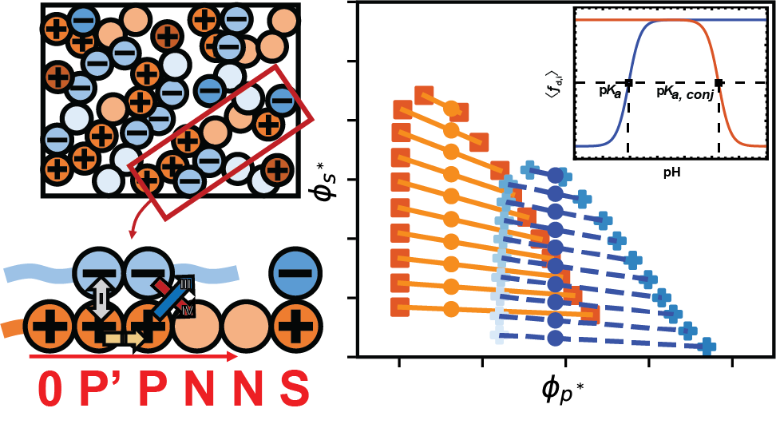

# 23. Nanoparticle Assembly in High Polymer Concentration Solutions Increases Superlattice Stability

Margaret S. Lee  
Alfredo Alexander-Katz  
Robert Macfarlane

Department of Materials Science and Engineering  
MIT

Polymer nanocomposites are made by combining a nanoscale filler with a polymer matrix, where polymer-particle interactions can enhance matrix properties and introduce behaviors distinct from either component. Manipulating particle organization within a composite potentially allows for better control over polymer-particle interactions, and the formation of ordered arrays could introduce new, emergent properties not observed in random composites. However, self-assembly of ordered particle arrays typically requires weak interparticle interactions to prevent kinetic traps, making these assemblies incompatible with most conventional processing techniques. As a result, more fundamental investigations are needed into methods to provide additional stability to these lattices without disrupting their internal organization. The addition of free polymer chains to the assembly solution is a simple means to increase the stability of nanoparticle superlattices against thermal dissociation. By adding high concentrations (>50 mg/mL) of free polymer to nanoparticle superlattices, it is possible to significantly elevate their thermal stability without adversely affecting their ordering. Moreover, polymer topology, molecular weight, and concentration can also be used as independent design handles to tune this behavior. This allows for a wider range of processing conditions for generating future nanocomposites with control over particle organization within the material.

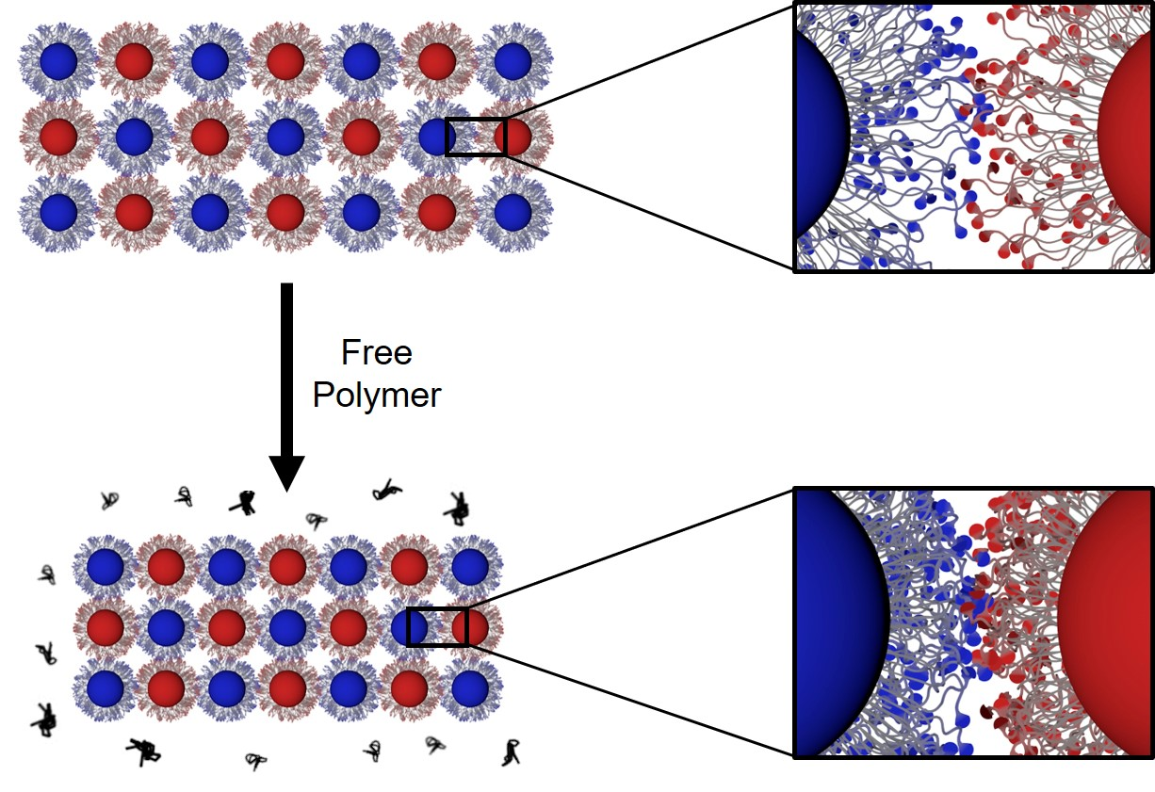

# 24. AuTopology: Conductivity and Solvation Analysis of Solid Polymer Electrolytes for Li Batteries Using a Local Atomic Environment-Specific Machine Learning Framework and Atomistic Simulations

Pablo A Leon

MIT, Department of Materials Science and Engineering

Solid polymer electrolytes (SPEs) are seen as promising alternatives to conventional liquid electrolytes in lithium battery systems due to their low density, mechanical compliance, and low flammability. However, the discovery of SPEs is difficult because of low solvation and negative lithium transference numbers. Molecular dynamics (MD) simulations can be used to guide the design of novel SPEs by allowing quantitative determination of separable anion and cation diffusions as well as local solvation environments. Classical potential MD simulations update molecular conformations by calculating the net force on each atom using interatomic potential models such as harmonic bonds, angles and torsions as well as Coulomb and dispersion interactions. However, these classical potentials require the prior knowledge of materials- and local environment-specific parameters such as unique bond stiffnesses, which are often not well defined.

Machine learning can be used to fit the atomic environment-specific parameters of classical potential models to recreate DFT-computed forces and energies. By combining the generalizability of machine learning with the interpretability and reliability of classical force fields, simulations can be performed to high degrees of accuracy at low computational costs. An in-house, neural network-based workflow, named AuTopology, learns interatomic potential parameters of distinct atomic environments from DFT forces as training data. Using this framework and an in-house database of molecular conformations, we have been able to reproduce wB97XD3-level DFT forces from trained OPLS force fields to within 5.5 kcal/mol-A as well as reproduce condensed phase solvation and mean squared displacements in PEO-LiTFSI electrolytes at experimental conditions and concentrations.

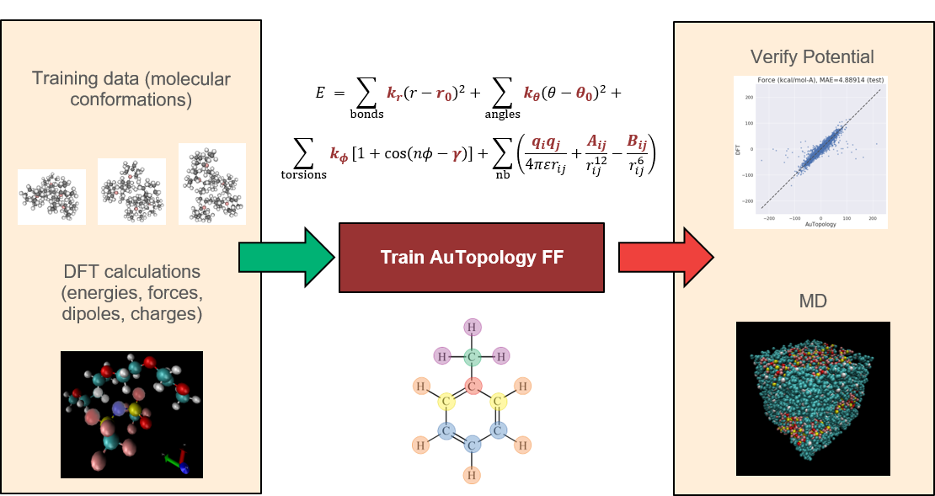

# 25. Sorption-enhanced mixed-gas transport in functionalized polymers of intrinsic microporosity (PIMs)

Katherine Mizrahi Rodriguez, Francesco M. Benedetti, Naksha Roy, Albert X. Wu, and Zachary P. Smith

MIT Materials Science and Engineering and MIT Chemical Engineering

Polymers of intrinsic microporosity (PIMs) have shown excellent pure-gas separation performance due to their rigid backbones, inefficient packing, and high free volume. Their out-of-equilibrium packing structures, however, make PIMs susceptible to physical aging and their intrachain rigidity alone has shown insufficient to mitigate plasticization. Moreover, pure-gas transport performance for PIMs rarely matches mixed-gas performance for industrially relevant conditions. For instance, a number of studies on the mixed-gas transport of PIMs have shown the effects of competitive sorption on separation performance, where gases with high polymer affinity (e.g., CO2) can reduce the sorption of co-penetrants in a mixture (e.g., CH4, N2) and increase selectivity. However, due to CO2-induced plasticization at high pressures, decreases in diffusion selectivity can outweigh beneficial competition effects. This trade-off in performance is especially detrimental for PIMs with little CO2 affinity and poor plasticization resistance, as they rely primarily on diffusion-selective transport that may be significantly reduced at high pressure.   
Here, we report on mixed-gas transport properties of polymers of intrinsic microporosity (PIMs) with identical benzodioxane backbones, but a diverse set of backbone functionalities. Low-pressure mixed-gas tests indicate a relationship between CO2 sorption affinity and enhancements in CO2/CH4 and CO2/N2 mixed-gas selectivity compared to pure-gas scenarios. The amine-functionalized PIM-1 (PIM-NH2), showed an unprecedented 140% and 250% increase in mixed-gas CO2/CH4 and CO2/N2 mixed-gas selectivity, respectively, compared to pure-gas. Moreover, PIM-NH2 films retained a CO2/CH4 mixed-gas selectivity over 20 up to a total mixed-gas pressure of 26 bar, demonstrating strong plasticization resistance compared to pristine PIM-1. Pure-gas sorption and mixed-gas permeation performance for the six PIMs were¬ compared across a range of reported microporous polymers, elucidating structure/property relationships that can enable rational design of high-performance chemistries for industrially relevant scenarios. Results demonstrate the promise of primary amine functionalization for developing highly sorption-selective and plasticization-resistant membranes for gas separations.

# 26. Mesoscale Polymer Ribbons as Hierarchical Building Blocks and Dynamically-Bonded Adhesives

Demi E. Moed, Dylan M. Barber, Alfred J. Crosby

Polymer Science & Engineering Department, University of Massachusetts Amherst

Nature relies on hierarchical assembly to construct a variety of specially functionalized parts from relatively few building blocks. In these assemblies, the mesoscale order, with feature sizes spanning hundreds of nanometers to tens of microns, is critical in determining the system’s functionality. For example, both tension-bearing tendons and compression-resistant bone include triple-helical collagen fibers, yet exhibit widely different properties by virtue of their hierarchical organization. The ability to similarly control synthetic materials’ performance through mesoscale structure is advantageous for several applications; however, current methods for controlling structure at this length scale are limited. Using long, flexible structures, called mesoscale polymer ribbons, we aim to demonstrate and understand how to use interfacial interactions in aqueous media to control the morphology and properties of multi-ribbon assemblies. We present preliminary data illuminating the impact of ambient salinity, pH, and aging on the morphology of mesoscale polymer ribbon brushes in aqueous environments. Mesoscale polymer brushes have potential applications as flexible, dynamically-bonded adhesives that bridge solid-liquid interfaces. By developing a thorough understanding of adhesion and assembly of multi-ribbon mesoscale structures, we provide an important platform within the framework of fabricating bioinspired hierarchical assemblies from soft materials.

# 27. GLAMOUR: Graph LeArning over MacrOmolecUle Representations

Somesh Mohapatra, Joyce An, Rafael Gómez-Bombarelli

Department of Materials Science and Engineering, Massachusetts Institute of Technology

Macromolecules are large, complex molecules composed of covalently bonded monomer units, existing in different stereochemical configurations and topologies. As a result of such chemical diversity, representing, comparing, and learning over macromolecules emerge as critical challenges. To address this, we developed a macromolecule graph representation, with monomers and bonds as nodes and edges, respectively. We captured the inherent chemistry of the macromolecule by using molecular fingerprints for node and edge attributes. For the first time, we demonstrated computation of chemical similarity between 2 macromolecules of varying chemistry and topology, using exact graph edit distances and graph kernels. We also trained graph neural networks for a variety of tasks for glycans and peptides data sets, achieving state-of-the-art results. Our work has two-fold implications – it provides a general framework for representation, comparison, and learning of macromolecules; and enables quantitative chemistry-informed decision-making and iterative design in the macromolecular chemical space.

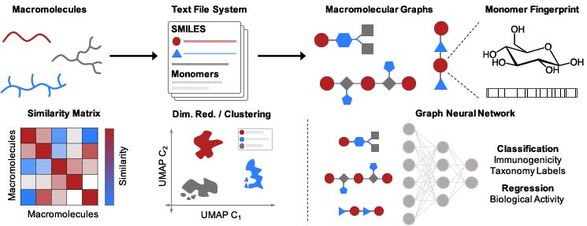

# 28. Isotactic Polypropylene Fibers in Melt-Blown Filter Media

Farshad Nazari, Mohammad Reza Rahimpour

Shiraz University   
Florida State University

The process for making meltblown isotactic polypropylene (iPP) fibers is discussed. The effect of molecular weight (MW) on the fiber size was investigated. With strong draw forces at the iPP-air interface and in the presence of high MW iPP, the crystalline structure of the iPP transitioned from spherulites to shish-kebabs. Due to the super-hydrophobicity of the fibers with shish-kebabs at the surface, these fibers had enhanced charge retention. This had significant effects on filtration efficiency for the most penetrable particle size (~0.3 um). We optimized our melt-blown process as well as formulations (blends of high and low MW iPP) in order to maximize charge retention and thereafter the filtration efficiency of the filter mat.

# 29. Understanding Solvation of Cellulose in Ionic Liquids by Time-Dissolution-Concentration Superposition Rheometry

Crystal E Owens  
Pablo Sanchez  
Jianyi Du  
Gareth H. McKinley

MIT, USA  
University of Vigo, Spain

Cotton-based textiles are a ubiquitous class of manmade material, and cellulose, which is a main ingredient of natural fibers, is the most abundant organic polymer on Earth. However, due to strong interchain hydrogen-bonding interactions, cellulose does not dissolve readily in common solvents, making it difficult to process and recycle cellulosic materials. Ionic liquids have been shown to disrupt these hydrogen bonds and thus solvate cellulose so that cellulose-based solutions can be processed like other common polymers. We monitor the dissolution of cotton-based textiles in 1-ethyl-3-methyl-imidazolium acetate [EMIM][OAc] over time using dynamic rheometry. We outline a new “time-dissolution-concentration superposition” principle, analogous to time-temperature superposition, to understand and predict the time scales and mixing strength required to dissolve and process cellulose over a wide range of weight concentrations (0.5 ≤ c ≤ 5%). We further characterize the extensional viscosity and relaxation time of this liquid over the same concentrations using Capillary Breakup Extensional Rheometry (CaBER) to evaluate the spinnability of the solutions into new cellulosic fibers. Together, this information is useful to guide the processing of cellulose into new synthetic fibers, and the formation and recycling of cellulose-based materials overall.

# 30. Supramolecular Assembly: How Does Local Packing of Identical Molecules Select Equilibrium Complex Crystals?

Abhiram Reddy, Gregory Grason

Polymer Science & Engineering, University of Massachusetts, Amherst

Connecting molecular design to nanostructure formation is one of the grand challenges of material science research in recent times. For a variety of soft matter systems it has been established that hierarchical self-assembly of these macromolecules as a result of microphase separation leads to ordered morphologies with varying symmetry. In this talk, I will focus on double gyroid(DG) morphology which is a composite crystal made up of two non-intersecting triply periodic chiral channels and a matrix phase. Formation of DG in self-assembled block copolymer(BCP) melts, along with understanding molecular-scale mechanisms behind its equilibrium selection, has been a topic of longstanding interest in polymer physics. In this talk, I will revisit equilibrium DG using a geometric theory for block copolymers which is valid in an asymptotic limit of conventional mean field theory used to model this many body problem and study equilibrium phase behavior. I will introduce a new variational method based on tessellations using medial set construction to compute space filling optimal chain packing within DG and show that our approach qualitatively alters the equilibrium phase diagram. Our medial model can also be extended to morphologies beyond networks and is easily adaptable to study packing frustration using simulation or experimental data thereby providing valuable insights to engineer molecular design to target yet unrealized novel self-assembled BCP morphologies.

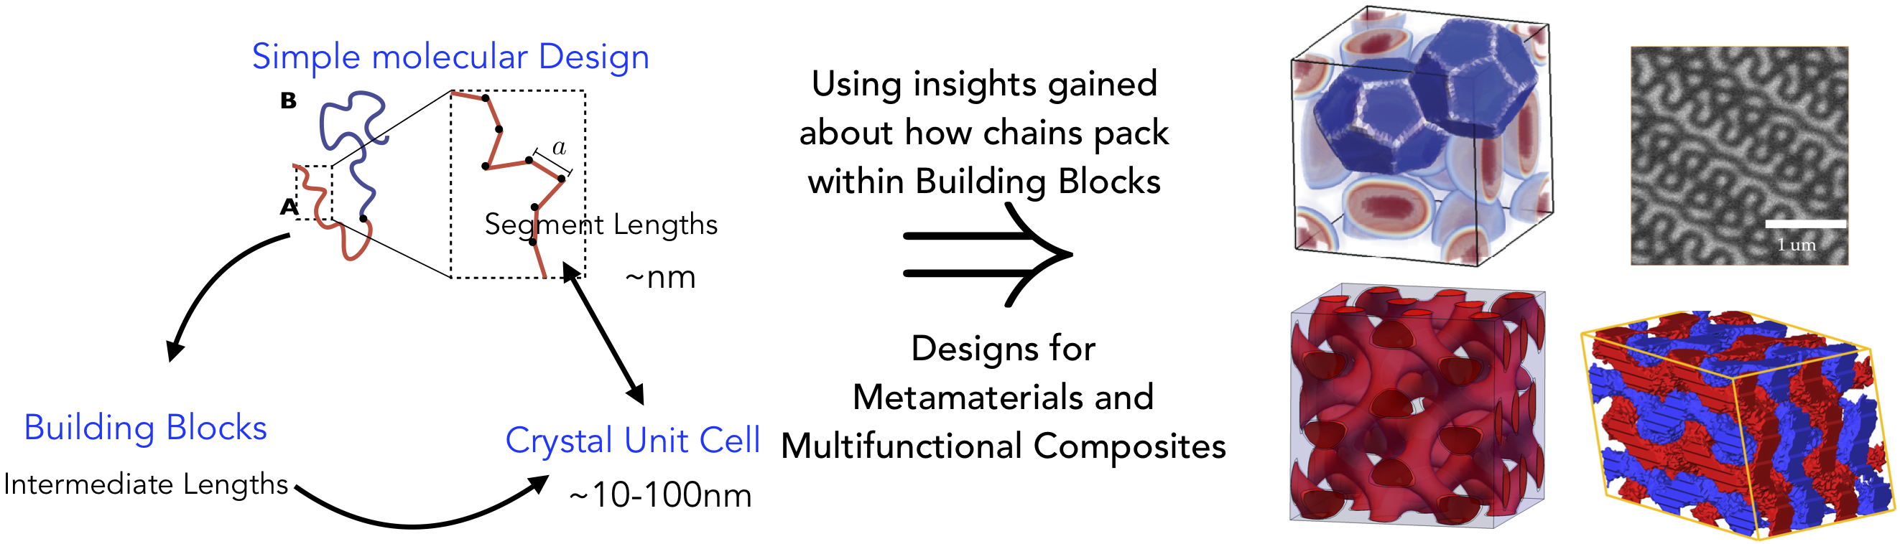

# 31. Surface initiated polymerization from polyolefin surfaces for biomedical applications

Kelsi M.S. Rehmann, Dr. John Klier, Dr. Jessica D. Schiffman

KMSR, JDS: University of Massachusetts-Amherst  
JK: University of Oklahoma

Medical devices such as catheters and joint prosthetics benefit from lubricious coatings. However, physicians and the Food and Drug Administration report biomedical coatings may leach particulates, detach from the substrate, and travel through patients' bodies to potentially cause arterial blockages (embolisms). Since most lubricious coatings are applied and cured on the surface, better adhesion and durability could be attained by covalently bonding the coating to the substrate. Surface-initiated polymerization has been used to graft thin polymer films to the surfaces of bulk polymer substrates coated with immobilized initiators. Here, we demonstrate surface functionalization to poly(ethylene-co-acrylic acid), which can be used as a co-crystalizable additive to a poly(ethylene) substrate, by using the carboxylate group to initiate surface polymerization of diethyl methylidene malonate at ambient, atmospheric conditions. Attenuated total reflectance Fourier transform infrared spectroscopy is used to demonstrate the chemical functionalization of the surface with poly(diethyl methylidene malonate). Through this approach, we propose to use methylidene malonate chemistries as covalently attached anchors for biomedical coatings, which we hypothesize will promote adhesion and durability.

# 32. Poly(I:C) Delivery Strategies to Selectively Activate TLR3 and MDA-5 Pathways for Immunotherapy

Apoorv Shanker, Imane Bouzit, Sandeep T. Koshy, Janelle Velez, Stephanie Schwartz, Paula T. Hammond

Apoorv Shanker: Koch Institute for Integrative Cancer Research, MIT  
Imane Bouzit: Biological Engineering, MIT  
Sandeep T. Koshy, Janelle Velez, Stephanie Schwartz: Novartis Institutes for BioMedical Research Paula T. Hammond: Koch Institute for Integrative Cancer Research, MIT; Chemical Engineering, MIT

Among the various toll-like receptor (TLR) agonists, polyriboinosinic acid:polyribocytidylic acid (poly(I:C)), a synthetic mimic of viral dsRNA, has been shown to activate and boost antigen cross-presentation by dendritic cell (DCs), promote NK cell cytotoxicity, and effect direct tumor-killing to generate tumor-associated antigens for DC presentation. Poly(I:C) is recognized by the endosomal receptor TLR3 and the cytosolic receptors RIG-I and MDA-5. It activates the transcription factors NF-κB and IRF leading to the production of pro-inflammatory cytokines (via TLR3) and type-I interferons (via MDA-5), respectively. Despite its potent immunogenic properties, safety concerns over inadvertent immune over-stimulation and short half-life in vivo have limited the scope of poly(I:C). Several strategies including liposomal and polymeric encapsulation, polycationic complexes or polyplexes, and surface-assembly on nanoparticles (NPs) or microparticles (MPs) have been explored to overcome these issues.

Here, we present a comparative study of poly(I:C) polyplexes and layer-by-layer (LbL)-assembled NPs/MPs carrying poly(I:C) to selectively activate the TLR3 and MDA-5 receptors. Poly(I:C) delivery platforms were fabricated using three classes of polycations: polypeptides, polysaccharides, and synthetic polymers. Dynamic light scattering, zeta potential measurements, gel electrophoresis, fluorophore exclusion titration assay, and circular dichroism were employed to characterize the polyplexes and assess the structural integrity of poly(I:C) complexed with different polycations. LbL microparticles were built on a negatively-charged core using the polycations to electrostatically assemble poly(I:C) on the particle surface. Using the HEK-Blue mTLR3 reporter cell line, TLR3 activation by the polyplexes was found to be roughly inversely correlated with the poly(I:C) binding strength of the polycations. While poly(I:C)-loaded LbL particles were as effective as free poly(I:C) in activating TLR3 when in direct contact with the cells, significant loss of bioactivity was observed when the cells and the particles were separated using a trans-well, likely due to enhanced cellular uptake of the LbL particles or degradation of poly(I:C) released from the LbL particles in the latter case. The selectivity of polyplexes and LbL particles toward TLR3 and MDA-5 receptors was assessed in A549 dual cell line. Compared to polyplexes, LbL microparticles resulted in greater activation of the cytosolic MDA-5 receptor and didn’t generally inhibit activation of endosomal TLR3 receptor. We elucidate the role of the delivery mechanism and polycationic carriers in stabilizing poly(I:C) against serum nucleases, reducing cellular toxicity and selectivity toward endosomal or cytosolic receptors. The presented biophysical studies provide critical insight into the design of poly(I:C) delivery platforms toward more potent adjuvants.

# 33. Equilibrium particle hydrogels with morphological tunability via limited valency interactions

Jake Song, Brian Lynch, Mehedi Rizvi, Jan Ilavsky, David Mankus, Joseph B. Tracy, Niels Holten-Andersen, Gareth H. McKinley

Massachusetts Institute of Technology, North Carolina State University, Argonne National Laboratory, USA

Limited valency interactions are predicted to facilitate the controlled self-assembly and arrest of particles into phase-stable and morphologically tunable “equilibrium” gels, which avoids the arrested phase separation and subsequent aging that is typically observed in traditional particle gels with isotropic interactions. Despite these predicted features of so-called “patchy” interactions for designing particle gels, patchy particle gels have yet to be realized in the laboratory due to experimental limitations associated with synthesizing such particles in high yield. Here, we introduce a supramolecular metal-coordination platform consisting of metallic nanoparticles linked by telechelic polymer chains, which undergoes equilibrium gelation through limited valency interactions. We demonstrate that the interaction valency and self-assembly of the particles can be effectively controlled by adjusting the relative concentration of polymeric linkers to nanoparticles, which enables the equilibrium gelation of the nanoparticles into hydrogels with programmable local anisotropy, morphology, and low mechanical percolation thresholds. Moreover, by crowding the local environment around the particles with competing interactions, we introduce an independent method to control the self-assembly of the nanoparticles, thereby enabling the design of highly anisotropic particle hydrogels with substantially reduced percolation thresholds. We anticipate these findings to inform future design of soft particle gels for structural and biomedical applications.

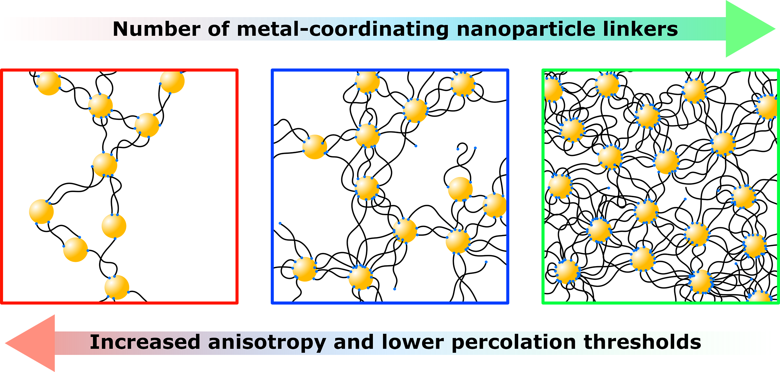

# 34. The Next Chapter of Sequence-Controlled Polymerizations: Single Molecule Insertion

Christian D. Steinmetz1, Rohit Gupta1, Abhiram Reddy1, Michael Dimitriyev1, Wenpeng Shan2, Xueyan Feng2, Edward Bryan Coughlin1, Edwin Thomas2, Gregory Grason1

1. Department of Polymer Science and Engineering, University of Massachusetts Amherst, Amherst, MA  
2. Department of Materials Science and Engineering, Texas A&M University, College Station, TX

Controlling the primary structures of the polymer chain in a chain-growth polymerization is synthetically challenging due to the difficulty in tuning the reactivity of the highly reactive transient species (radicals or ions). Maleimides represent a class of monomers that cannot homopolymerize under radical conditions but possess a strong cross-propagation behavior with styrene leading to strictly alternating copolymers. Macro-RAFT-CTAs of either Poly(methyl methacrylate) (PMMA-macro-CTA) or Poly(styrene) (PS-macro-CTA) can only insert one single molecule of a pentafluoro phenyl maleimide ester (PFPMI) upon  
reinitiation if styrene is absent. Through the favored cross-propagation of these terminal maleimidic macro-radicals with styrene, a PS block can now be grown with high control over molecular weight and low dispersities. This gives access to either PMMA-PFPMI-PS diblock copolymers with one graftable unit at the block junction or PS-PFPMI-PS’ homopolymesr with one graftable unit along its backbone at a predefined postition. Post-polymerization functionalization with amino functionalized polymers expands the palette to unprecedented asymmetric multiblock copolymer architectures.

# 35. Highly Ordered Single Ion Conducting Polymer Electrolytes for Decoupled Ion Transport

Michael A. Stolberg, Yang Shao-Horn, Jeremiah A. Johnson

Department of Chemistry, MIT (MS, JAJ)  
Department of Materials Science and Engineering, MIT (MS, YSH)

Polymers have potential to create safe and effective electrolytes for lithium ion batteries. However, most state-of-the-art polymer electrolytes suffer from low room temperature conductivity and have transference numbers less than 0.5. These problems stem from the lithium ion mobility being coupled to the segmental motion of the polymer matrix. A possible solution is single ion conducting polymers, in which the anions are covalently bound to the polymer backbone. Herein we present novel single ion conducting polymers that have anions precisely spaced along a polyethylene backbone. This allows for crystallization driven self-assembly creating anionic channels. We show that these self-assembled structures form robust films capable of ion conduction that is decoupled from the crystalline polymer matrix.

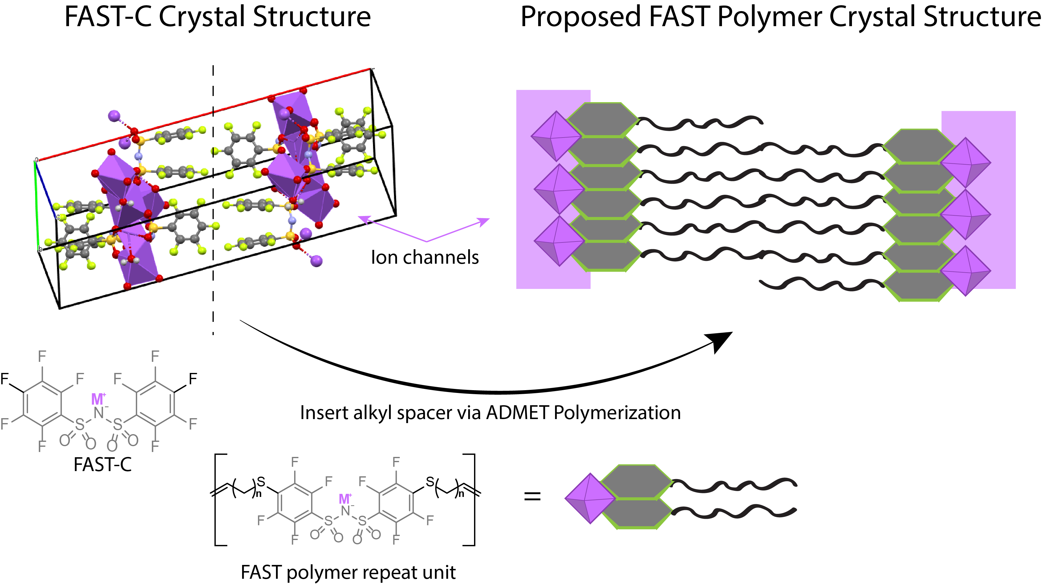

# 36. Effects of lithium chloride on the solid state properties of polyzwitterions

John Thomas, Andrew Clark, Yajnaseni Biswas, Ayse Asatekin, Peggy Cebe

Department of Physics and Astronomy, Tufts University, Medford MA - John Thomas, Andrew Clark, Peggy Cebe  
Department of Chemical and Biological Engineering, Tufts University, Medford MA - Yajnaseni Biswas, Ayse Asatekin

Polyzwitterions (PZIs) have properties such as ionic conduction, thermal stability, and mechanical stability, making them prime candidates to be used as solid polymer electrolytes [1]. In this study we investigate thermal properties of the solid state for poly(sulfobetaine acrylate), PSBA with and without added salt. This PZI can dissolve molar ratios of salt which increases its electrical conductivity. We added LiCl to PSBA at 1-20 wt.% and studied the impact of added salt on water uptake, degradation temperature, solid state heat capacity, and the glass transition temperature, Tg. Thermal gravimetry shows the percentage of bound water ranges from 5-18 wt.%, and increases as LiCl content increases. Using differential scanning calorimetry, we perform cyclic heating and cooling studies where each successive heat cycle reaches a higher maximum temperature. This “ratchet method” allows systematic removal of bound water and observation of the plasticization effect on Tg. Results show that addition of LiCl reduces the glass transition of dry PSBA (i.e., containing no bound water) from ~200°C to 150°C for the PSBA/LiCl composite at a 1:1 molar ratio.

# 37. Molecular Engineering of Polyelectrolyte-Micelle Complexes

Hansen Tjo, Sarah L. Perry

Hansen Tjo (1), Sarah L. Perry (1,2)  
1. Department of Chemical Engineering, University of Massachusetts Amherst  
2. Institute for Applied Life Sciences, University of Massachusetts Amherst

In solution, electrostatic complexation may drive oppositely-charged macro-ions to undergo associative phase separation into a complex coacervate phase – a dense, polyelectrolyte-rich liquid with widespread applications across a range of industries — and a dilute phase, the supernatant. The widespread applications of coacervates for molecular separation and controlled delivery have resulted in extensive analysis of the phase behavior and properties of polyelectrolyte-micelle systems. However, much of the work to date has focused primarily on a very narrow range of conditions. Thus, we seek to develop general design principles governing self-assembly in a broad range of coacervate systems.

Electrostatic interactions govern coacervate phase behavior, with an expected 1:1 charge ratio between the charged macro-ions. Nonetheless, the mixed-micelle nature of polyelectrolyte-micelle coacervates results in a ternary system that introduces an additional variable Y: the micellar charge fraction. The critical micellar charge fraction Yc, where complexation is induced, is a parameter frequently used to characterize polyelectrolyte-micelle systems and has been shown to vary as a function of polymeric and micellar chemistries.

We hypothesize that the charge densities of both the polymer and micelle affect overall phase behavior, which we can test by varying polymeric charge densities and by using steric exclusion to decrease the apparent micellar charge density. Specifically, we use turbidimetry coupled with optical microscopy to characterize the phase behavior of a series of cationic random copolymers of varying charge densities with a panel of anionic mixed-micelles with different neutral hydrophilic head group sizes. Preliminary results support our hypothesis: for a given mixed-micelle, we saw a positive shift in Yc with decreasing polymer charge density. In other words, a polymer of a lower charge density requires a micelle of a higher surface charge density in order to form coacervates. Moreover, for a given polymer we observed that increasing levels of steric exclusion correlated with increases in Yc; we believe these steric effects functionally decrease the micellar surface charge density. We are now applying electrophoretic light scattering to quantify the relationship between the zeta potentials of each cationic co-polymer and anionic mixed-micelle with the critical micellar charge fraction Yc of their corresponding polymer-micelle complex. Our goal is to establish design rules accounting for the effective charge density of each macro-ion to facilitate the tailored design of materials for biomedicine.

# 38. Quantifying Interfacial Fracture in Geometrically Confined Soft Elastomers by a Combined Analysis of Contact Force and Pressure

Hares Wahdat  
Alfred J. Crosby

Hares Wahdat - University of Massachusetts Amherst, Polymer Science and Engineering Department  
Alfred J. Crosby - University of Massachusetts Amherst, Polymer Science and Engineering Department

Interfacial fracture occurs in many different situations ranging from the failure of polymer adhesives to the growth of wounds in human skin. Commonly, interfacial fracture can be studied by inserting a needle into a soft material and apply positive pressure while recording images. The combination of pressure and corresponding images has revealed insight into the interfacial fracture properties of gels or biological tissues. Still, the need for recording images can complicate the study of non-transparent samples or in-vivo studies. Here, we present experiments, in which the pressure-change and the corresponding contact between a rigid probe in contact with soft elastomers, were analyzed to quantify the critical strain energy release rate for interfacial fracture, Gc. The calculation of Gc does not require image recording making our experiment and analysis suitable for in-vivo studies of fracture.

# 39. Nematic Colloids at Liquid Crystal-Air Interfaces via Photopolymerization

Xiaoshuang Wei, Nicholas Sbalbi, and Laura C. Bradley

Department of Polymer Science and Engineering, University of Massachusetts Amherst

Liquid crystals (LCs) have been shown to control the organization and location of colloidal assemblies ranging from chain-like to hexagonal structures. Most systems that exploit LC-mediated assembly for producing colloidal superstructures require the use of pre-synthesized particles or temperature-induced phase separation. Here, we demonstrate simultaneous synthesis and assembly of colloidal assemblies at LC-air interfaces. Polymer colloids are produced by photopolymerization of an acrylate monomer mixed in a non-reactive liquid crystal. Colloids spontaneously form ordered assemblies that cover the entire area of the LC-air interface. Systematic experiments varying the reaction time were conducted to monitor the growth and assembly. Our results demonstrate the design rules for producing nematic colloids at LC interfaces via photopolymerization which can offer opportunities for the preparation of large-scale LC-templated interfacial superstructures.

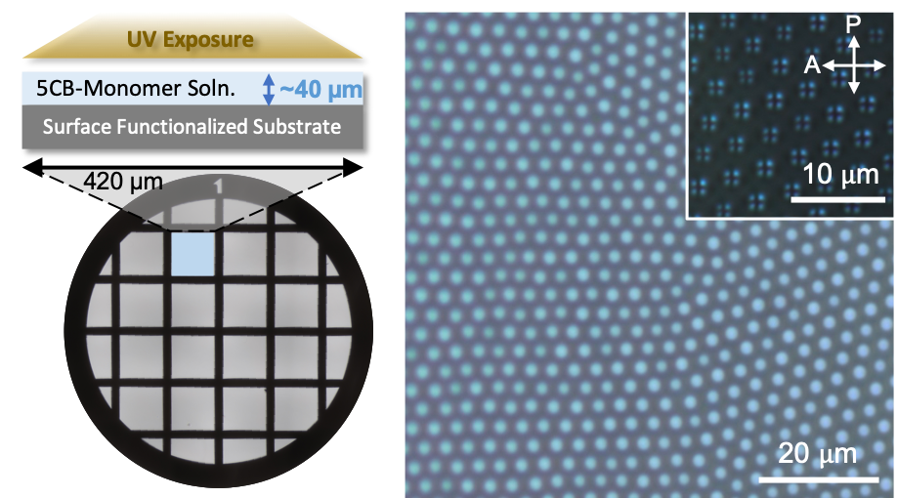

# 40. Elastically Controlling the Positions of Solid Micro-plates on Curved 2D Fluids

Weiyue Xin  
Maria Santore

1. Department of Chemical Engineering, University of Massachusetts Amherst,   
2. Department of Polymer Science and Engineering, University of Massachusetts Amherst

This work explores the reversible interactions between solid microplates in 2D fluid membranes that result from the manipulation of curvature and developed the ability to elastically control the positioning of these solid plates on curved 2D fluids. To quantify the positions of the minima in pair potentials between solid domains, we developed a systematic method to produce giant unilamellar vesicles having specific numbers (1,2 or 3) of solid domains of nearly similar size. In contrast to previous work which has only reported repulsive or attractive interactions to happen individually, our work discovers a distinct minima potential within solid domain pairs results from the shear elasticity of solid domain. We also discovered the ability to toggle interactions and shift the targeted positioning by osmotic adjustment or mechanical manipulations using micropipettes. This work suggests a new picture that allows tunable interactions to form sophisticated responsive patterns on 2D materials.

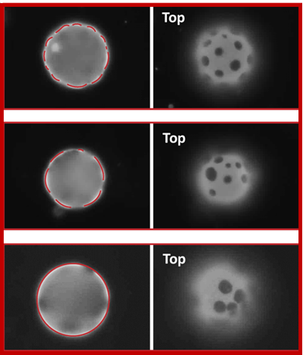

# 41. Additive manufacturing of high aspect-ratio structures with self-propagating polymer waveguides

Mingyu Yang, Kavin Kowsari, Anna Jagielska, Krystyn Van Vliet

Mingyu Yang: Harvard-MIT Health Sciences and Technology, Massachusetts Institute of Technology  
Kavin Kowsari: Departmental of Mechanical Engineering, Massachusetts Institute of Technology  
Anna Jagielska: Department of Materials Science & Engineering, Massachusetts Institute of Technology  
Krystyn Van Vliet: Department of Materials Science & Engineering, Department of Biological Engineering, Massachusetts Institute of Technology

Photopolymers have been used to recent and impressive advantage for printing freestanding, micrometer-scale, mechanically compliant features. However, a more integrated understanding of both the polymers and the process can enable more rational design and more far-reaching applications of such additive manufacturing. A promising approach for achieving high-aspect ratio structures is to leverage a phenomenon termed ‘light self-trapping’ during the photopolymerization process. We discuss the design of photopolymer materials that facilitate this phenomenon, in addition to the range of applications that can leverage these printed materials. Furthermore, we present our recent work in fabricating free-standing, biocompatible ‘Artificial Axons’ through self-focusing photopolymerization.

# 42. Non-equilibrium dynamics of ring-linear polymer solution blends

Charles D Young, Yuecheng Zhou, Charles M Schroeder, Charles E Sing

Department of Chemical and Biomolecular Engineering, University of Illinois at Urbana-Champaign

The non-equilibrium dynamics of polymer solutions are relevant to many coating, spinning, and printing flows used in polymer processing. The broad parameter space of polymer solutions provides great functional versatility in designing viscoelastic flow behavior and material properties. However, this also causes challenges in quantitatively predicting the polymer conformations, which are intrinsically linked to continuum properties. We develop an understanding of the effect of polymer concentration, chain architecture, and applied strain rate on polymer dynamics using Brownian dynamics simulations with hydrodynamic interactions (HI) and topological constraints. We consider blends of ring and linear polymers in planar extensional flow at concentrations from nominally dilute (0.1c*) to semidilute (3c*). We control polydispersity via the mass fraction and molecular weight ratio of ring versus linear polymers. When the maximum stretch in the flow direction is the same for ring and linear chains (LL/LR = 1, ML/MR = 0.5), the dynamics match the expected coil-stretch transition found previously for dilute and semidilute polymer solutions. When the linear polymer molecular weight is matched to that of the rings (LL/LR = 2, ML/MR = 1), we find a distinct departure in the ring dynamics, including ring extension overshoots in startup flow and large conformational fluctuations at steady state. The steady state conformational fluctuations further increase with size disparity up to LL/LR = 4, ML/MR = 2. We find that the overshoots in ring extension are caused by intermolecular hooks between ring and linear polymers, and the steady state fluctuations are caused by intermolecular HI between the highly stretched linear chains and weakly stretched rings. We show that these conformational fluctuations are related to transient local deviations from planar extensional flow on the length scale of the smaller component. Fluctuations grow with concentration and mass fraction of linear polymers due to the increased perturbation of the solvent velocity.

# 43. Rapid Mesoporous Carbon Nanoparticle Composite Fabricated via Microsecond Photothermal Process Without Ostwald Ripening

Hsin-Jung Yu, Huafeng Fei, Kenneth Carter, James Watkins.

Polymer Science and Engineering, University of Massachusetts

Mesoporous carbon containing well dispersed crystalline nanoparticles are interesting high performance material. Here, we demonstrate a novel microsecond light pulse carbonization process that produces large area mesoporous carbon films containing well-dispersed titania nanoparticle. The process involves a bottlebrush copolymer which self-assembles into a spherical morphology. When combined with a phenol-formaldehyde resin which provided the carbon scaffold, and TiO2 nanoparticles were added to serve as a photocatalyst. In this study, a structure-property relationship was investigated for fast precursor formation of mesoporous carbon hybrid material. This mesoporous hybrid material resulted in a 1.5-fold improved degradation potential over the reference bulk titania. The photocatalytic neutralization potential was tested on both organophosphorus nerve agent and environmental hazardous simulant. Apart from photocatalytic activity of the dispersed TiO2 nanoparticles, the mesoporous structure also led to highly absorbent properties. More notably, this rapid photothermal process used to fabricate porous material can be potentially applied to the design many other multifunctional mesoporous carbon-metal oxide hybrid materials.

# 44. A acrylate-bearing phosphatidylcholine: study of self-assembly, polymerization and application in drug-delivery

Dawei Zhang, Robert Prudhomme

Chemical and Biological Engineering Dept., Princeton University

A acrylate-bearing phosphatidylcholine (PC) molecule was designed and synthesized. The acrylate-PCs are capable of assembly of bilayer membrane and corresponding liposomes. Polymerization of the acrylate-PC was triggered using photo-initiator in the bilayer membrane. Self-assembly of PC-polymer with various percentage of PC repeating units was investigated. The PC-grafting polymer was applied in flash nanoprecipitation process to prepare drug-loading nanoparticles which exhibits a cell-membrane-mimic surface.

# 45. Fluorinated Polymer Zwitterions: Choline Phosphates and Phosphorylcholines

Le Zhou, Alexandria Triozzi, Marxa Figueiredo, Todd Emrick*

University of Massachusetts, Amherst  
Purdue University

Among zwitterionic compositions, the choline phosphate (CP) group is uniquely attractive for its ability to access novel chemical compositions that embed functional groups directly into the zwitterionic structure. This paper describes the attachment of fluorinated alkyl groups to CP moieties, yielding zwitterionic monomers that are amenable to controlled free radical polymerization to yield a new set of CP-containing fluorinated polymers as well as block copolymers with phosphorylcholine (PC) zwitterions. This combination of fluorinated hydrocarbons and zwitterions affords novel, water soluble homo- and copolymer amphiphiles which prove useful as surface active agents and, by cell culture assays, appear to possess a low level of cytotoxicity in accord with the CP zwitterionic motif.

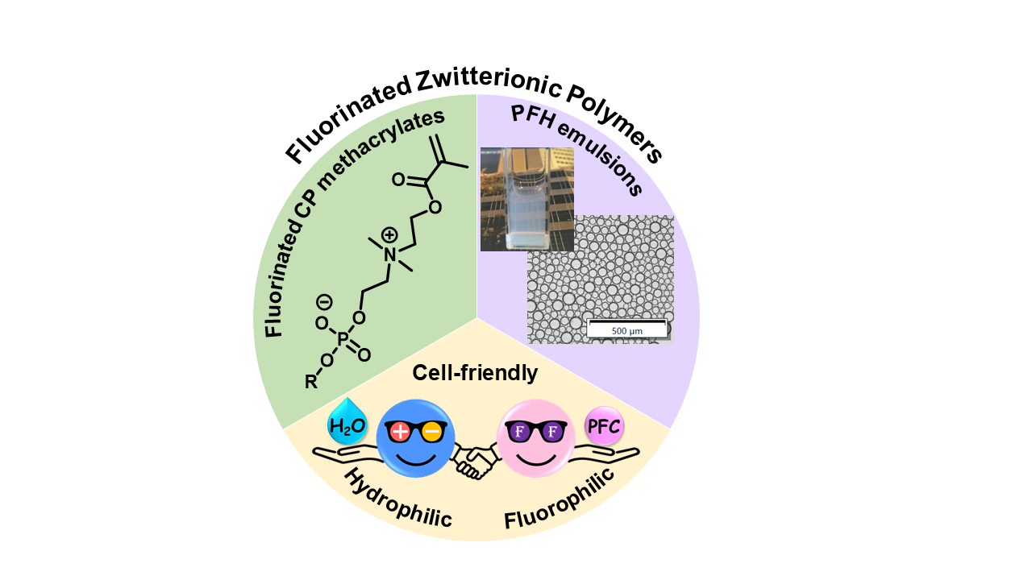

# 46. A Convergent Platform for Translating Synergistic Drug Combinations to Nanomedicines: Application to Multiple Myeloma Therapy

Alexandre Detappe,£ Hung V.-T. Nguyen,£ Yivan Jiang, Michael P. Agius, Wencong Wang, Clelia Mathieu, Nang K. Su, Samantha L. Kristufek, Irene M. Ghobrial,* P. Peter Ghoroghchian,* and Jeremiah A. Johnson*

Massachusetts Institute of Technology, Dana-Farber Cancer Institute, Harvard Medical School (£ and * denote equal contribution and co-corresponding authors, respectively)

Current anticancer agents continue to face substantial challenges, including inherently narrow therapeutic indexes (TIs) as well as suboptimal therapeutic combinations, stemming from mixtures of active pharmaceutical ingredients (APIs) with dissimilar properties. While nanomedicine-based platforms for drug delivery can potentially address these challenges, key questions remain, including “do synergistic free drug ratios translate to nanocarriers?” and “are nanocarriers with multiple drugs better than mixtures of single-drug nanocarriers at the same dose?”. Here, we report a prodrug platform that allows us to answer these questions in the context of advanced clinical therapies for relapsed multiple myeloma (MM), including bortezomib-based (Btz) monotherapy and combination therapies with Btz, pomalidomide (Pom), and dexamethasone (Dex). For Btz monotherapy, a Btz-“bottlebrush prodrug” (BPD) is designed that enables a 25-fold increase in API dosing when compared to Btz alone and without observable toxicities in mice. Moreover, Btz-BPD significantly slows tumor progression in vivo, providing marked enhancements in survival in subcutaneous and orthotopic models of MM. In the context of combination therapy, BPDs carrying Btz, Pom, and Dex exhibit in vitro synergistic, additive, or antagonistic patterns that are distinct from the free drug counterparts, which is a perhaps expected, yet undemonstrated, phenomenon. Moreover, a BPD carrying all 3 drugs in a synergistic ratio outperforms the free drug combination, mixtures of single- drug BPDs in the same ratio, as well as an antagonistic 3-drug BPD. Together, our results address unanswered questions in the field of combination nanomedicine, establishing a proof-of-concept for macromolecular prodrug-based approaches that are enabled by the unique BPD architecture in order to potentially improve current front-line mono- and combination therapies.

